LAUC

UNIVERSITY-WIDE RESEARCH GRANTS FOR LIBRARIANS

COVER SHEET

NOTE: Grant proposals are confidential until funding decisions are made.

INSTRUCTIONS: The applicant(s) must submit two (2) copies of their application packet. The application packet consists of the Cover Sheet and the Proposal. Applicants send 1 (one) printed copy of their application packet, with signatures, to the Chair of the divisional research committee, who forwards the packet to the Chair of the university-wide Research and Professional Development Committee. Applicants send the second copy of their application packet as an email attachment to the Chair of the divisional research committee who forwards it on to the Chair of the university-wide Research and Professional Development Committee.
Date of Application: October 14, 2006

Title of Proposal/Project: Índia Portuguesa: Improving Access To Portuguese Language Periodicals from Portuguese India
Expected Length of Project : 1 year

Total Funds Requested from LAUC University-Wide Research Funds: $7947.00

Primary Applicant
Your Name (include your signature on the paper copy): Liladhar R. Pendse

Academic Rank and Working Title: Associate Librarian, South Asian & Slavic/ Eastern European Studies

Bargaining Unit Member/Non-Member: Unit Member

Campus Surface Mail Address: Young Research Library, 11360, CRIS, UCLA,
Box 951575, Los Angeles, CA 90095-1575

Telephone and Email Address: 310-825-1639, Lpendse@library.ucla.edu

URL for home campus directory http://www2.library.ucla.edu/libraries/2049.cfm

The annotated bibliography of Periodicals of India Portuguesa (1821-1921) will be mounted on UCLA Library web-site with links to the South Asian Studies Resources webpage.

Co-Applicant(s)
Name: N/ A

Academic Rank and Working Title: N/A

Bargaining Unit Member/Non-Member: N/A
Campus Surface Mail Address:

Telephone and Email Address: N/A
Proposal Abstract (not to exceed 250 words):

The importance of print media as a vehicle for the expression of popular culture and associated rise of nationalism is a well studied fact. The rise of the Portuguese press in India can be used to document not only the evolution of popular culture in Índia Portuguesa, but it can also be viewed as a valuable tool in understanding various mechanisms that lead to the rise of a complex national identity. Portuguese periodicals that were published in Goa, India (1821-1962) are also an excellent source of such information. These periodicals provide us with a new perspective on mechanisms of colonization, cultural production, and public sphere. These periodicals are often overlooked by researchers in North America who study colonial theories due to the difficulty of access. The Library of Congress catalog lists one Indo-Portuguese periodical titled “O Heraldo”. The proposed project will address the difficulty of access issue. First, this project will pilot a program that will identify, and microfilm up to 5 such periodicals in Biblioteca Nacional, Lisbon. After microfilming, this project will digitize these microfilms. These microfilms will be deposited in the UCLA library. Second, a comprehensive web-bibliography of these 200+ periodicals will be created. Third, a research paper will be presented in an academic setting. I believe that this project will enable the North American specialists that are interested in studying the specificities of Portuguese colonization add an unique dimension to their research on social conditions and popular culture in the Metropole as well in the colonial India.

Does the proposal require any of the following:

Use of UC Library facilities or other site(s) requiring prior approval (Yes/No): No?

If yes, include signature and position of person authorized to permit use of
facilities on paper copy of application:
Release time (Yes/No): YES
If yes, include signature(s) of person(s) authorized to approve release time on
paper copy of application:

Signed on paper copy. Image included with this proposal in the appendix IV
--------------------------------------------------------------------
(Katalin Radics, PhD, Interim Head, CRIS, YRL)

Use of Human Subjects (Yes/No): No
If yes, attach appropriate university form to paper application form. The process of
obtaining IRB approval or a determination of exemption from subject protection
regulations does not have to be completed prior to submitting your grant proposal.
However, the grant cannot be awarded without evidence that the approval or
exemption has been obtained.

List any previous grant proposals (divisional and university-wide) from this program that have been awarded to the primary applicant or co-applicants by title. Include date of completion and amount funded: None

Budget Summary
Total amount requested from LAUC statewide research funds: $ 7947

Total amount requested from LAUC divisional research funds: $ NONE

Other funding obtained or expected (amount and source): $ NONE

Fiscal Year of Application (fiscal year that funding begins): 2007-2008
New Project (Yes/No): YES
Supplemental Funding (Yes/No): NO
Salaries:
1 LA IV Step 1 40 hours@ 18.70 =$748.00
Current LA IV has 50%
Position. I am seeking
additional funding.
Total Salaries: =$748.00

Supplies: $100 photocopying (for materials not obtainable in the original)

Total Supplies: =$100.00

Travel:

Total Travel: =$7099
Other Expenses: (Not requested from LAUC by this proposal, but included to indicate relevance of microfilming for further research)
Acquisition of selected sample issues of Indo-Portuguese Periodicals in Lisbon (from South Asia Collection Development Budget), microfilming of 5 periodicals, and digitization of these microfilms (all will be cataloged in UCLA Library catalog with records available in MELVYL). Please see attached price list from Biblioteca Nacional in Lisbon. = $3360
CRL Microfilming Cost Estimates Chart
(See: http://www.crl.edu/content.asp?l1=3&l2=15&l3=32)

Each Exposure $ 0.28 x 800 Exposures per 100 linear feet film = $ 224
15 Reels x $ 224= $3360
Exchange Rate = 1 USD = 0.78 Euro on January 25, 2007

Total Other Expenses:

Total State-Wide Research Funds Requested: $7947.00
Revised 9/200 bhg
 | Librarians Association of the  University of California

SUPPLEMENTAL BUDGET INFORMATION
This Sheet Must Accompany the Grant Application

PER DIEM
Please indicate the source of the per diem rates used in the application

- Federal Government : YES (http://www.state.gov/m/a/als/prdm/73533.htm)
- University (http://www.travel.ucla.edu/new/policy_calculating_per_diem.shtml)
- Other _____________________________________________________
d. Other _____________________________________________________

Location Rate Source

1. Lisbon 18 days @$248 per Diem = $ 4464
2 Porto 4 days @$182 per Diem =$ 728
3. Total Requested $ 5192
4.
5.

TRAVEL
Please indicate the source of the travel information used in the application

- Federal Government
- University
- Internet Search (list which service used)_Expedia___________
- Travel Agency
- Other ________________________________________________

Location Type Amount Rate Source

1 Airfare LAX-Lisbon Economy $1487.00 08-18-2007 through 09-05-2007?
2. Airf are Lisbon-Porto Economy $ 320.00 within the period of stay above
3. LAX-Home and return Shuttle $ 100.00
4. Total Requested $ 1907.00

INTRODUCTION AND NEED FOR RESEARCH

It is a well known fact that Vasco da Gama discovered in 1498, an overseas route to India, and thus began an era of persistent efforts by Europeans to gain a foothold on the Indian sub-continent. This discovery eventually culminated in the European colonization of India.
The colonial narratives and national discourse of the late nineteenth century in Portuguese periodicals published in India sheds light on various interactions between those who were colonized and the colonial masters. The Portuguese permanent colony of Goa was initiated in the early 16th century, and lasted until its liberation by Indian Union forces in 1961. The Portuguese, being the first European colonizers of India, were subsequently the last ones to leave. The lengthy tenure of the Portuguese is as an experience in state-building on a foreign soil that mandates further investigation into the nature of their rule. One way to examine the nature of their rule is through the Portuguese periodical press of the time.
The importance of print media as a vehicle for the expression of popular culture and the associated rise of nationalism is a well studied fact. Often times the print culture reinforced the paradigms of national identity as it aided in the standardization of the language.The print culture within a colonial framework evolved differently in different colonies. The rise of the Portuguese press in India can be used to document not only the evolution of popular culture in Goa and other territories of Índia Portuguesa, but it can also be viewed as a valuable tool in understanding various mechanisms that lead to the rise of a complex national identity. In its initial phases, the development of the press in the colonial territories can be examined as a function of the initiatives that the mother country implemented as well as that of the interests of the local elite as permitted by the mother country, and Goa in this was not an exception.
It is generally assumed that the appearance of Portuguese language periodicals in Índia Portuguesa facilitated the enhanced circulation of ideas from the metropole and the rest of the Europe. However, one can also state that the set of historical conditions that existed in metropole, when transported and implemented in Goa blossomed into a different end-product than in the metropole.
The Portuguese language periodicals could have acted as information-vectors that disseminated not only the information but various ideas to the colonial population. This dissemination of information at times complimented the goals of the Portuguese administrators of the ultramarine territories. Can one assume that in the long run this information dissemination could have led to the internalization of various “Portuguese” ideas by the literate populace of Goa?
Beginning in 1821, with the appearance of the first Portuguese newspaper in India Portuguesa, a new era in India Portuguesa’s history began. This era was characterized by hundreds of Portuguese language periodicals that circulated in the state. These Portuguese periodicals were published in various parts of India including Goa, Mumbai, Daman and Diu. These periodicals serve as an important testimony to colonization, because the contents of these periodicals narrate not only the story of acculturation and acceptation, but that of re-assertion of “native” identity and resistance to the colonial rule.
The periodicals of Índia Portuguesa are as diverse as the audience that they addressed, and subjects they covered, including literary, political, economic, and social, women’s issues in daily, weekly, monthly, quarterlies. These periodicals are often excluded by Western European historians as being outside their zone of expertise, and the Portuguese bibliographies that exist about these periodicals are not current and up to date. I consider these periodicals to be a treasure trove for North American researchers, because one can assume that the editorials of these periodicals will reflect various opinions about the Portuguese State building experience in India, especially during the Salazar period, where Estado da India had only one party system under the semi-fascist “União Nacional”. The editorials per se may not be radical given the state of censorship in which Estado da Índia existed in 1950s, but there is a large cultural data that needs further analysis to form a complete picture about the nature of Portuguese colonies in South Asia.
It has been more than 24 years since, Scholberg, Kakodekar, and Azevedo published in 1982, “Bibliography of Goa and the Portuguese in India”. The Scholberg bibliography deals with periodicals in a separate section, and does not contain all of the Portuguese periodicals that were published in India Portuguesa. For example, before this bibliography, we find a list of Portuguese Periodicals in Brito de Aranhas work titled, “Subsidios para a historia do jornalismo nas provincias ultramarinas portuguezas, pelo socio Brito Aranha” that was published in 1885. Jaime Rangel of Tipografia Rangel, Bastora at Goa in 1960’s published a bibliography.
Although all of these bibliographies deal with the periodicals, these bibliographies fail to indicate the subjects that these periodicals covered. I plan to create an annotated bibliography of all known Portuguese language periodicals of Portuguese India that were published between 1821 and 1921 as a part of this project. We should also look at the relationship of my bibliography to the National Bibliography of Indian Languages. The census of Goa just after reintegration in to the Indian Union fails to mention Portuguese as one of many languages that were spoken by the population of India Portuguesa. The Indian Union asserted its strong de-colonization practices in India Portuguesa, among these policies; we see an example of delimiting use of Portuguese in daily affairs of the State. Indian National bibliography also fails to reconcile these periodicals as a parcel of field of Indian cultural production. I believe that my project will help us address this deficiency.
This in turn leaves the scholars who are studying Portuguese colonialism at significant disadvantage for several reasons. First, as mentioned earlier, there are hundreds of these periodicals with varying degrees of longevity and subject matter. Second, the dynamics of Portuguese rule in India from 1821 onwards align not only with the “happenings” in the Metropole, but with the local political and social conditions. These conditions resulted in the dominance of “field of cultural production” by the generations of “lusitanized” Indians who spoke, wrote in Portuguese, and took part in various revolts against the perceived oppressive policies of the mother country. Third, the lack of subject indication in these bibliographies leaves the researchers with no clue so far as to what are the topics that might be covered. The scholars are often left with only guessing the contents based on the titles of the periodicals.
The Portuguese periodicals press further bears witness to the fact that the Portuguese enclaves in India were surrounded by British India. The influence of Goan intelligentsia that was educated in Bombay led to the creation of tensions and competing priorities within Goa and other Portuguese territories. Some of the bilingual Portuguese-Marathi, Konkani-Portuguese periodicals are also understudied and often escape due attention in the standard reference sources. These sources acquire an important character as the majority of the population of India Portuguesa communicated in Konkani or Marathi along side of Portuguese. One can never ignore the fact that Portuguese although was an official language of the Estado da India, was never a language that was spoken by the majority. However, it is probable that the information that was contained in these periodicals often times was conveyed using the word to mouth mechanisms.
For the sake of curiosity and this proposal, I did a search on periodicals that were published in Goa, in the Portuguese language using advance search features for UCLA library catalog, and I retrieved 10 titles. Of these items, “Jornal de pharmacia e sciencias medicas da India Portuguesa” published in 1862, was acquired by the Bio-Medical Library in September of 2006 for Walter Jarvis Barlow History of Medicine Collection Fund at my recommendation. This journal besides containing Medical and Pharmacological data contains the only available mortality rates in Estado da Índia for the year 1862. The socio-cultural briefs about Goa and Portuguese attitudes towards the level of sanitation within their territories are also included in it. This is an extremely rare journal and according to the WorldCat database (OCLC #50356368) only other 3 copies exist in AMSTERDAMSE UNIVERSITEITSBIBLIOTHEEK, Harvard University library, and National Library of Medicine in the United States.
I carried out a similar search using Harvard University’s Hollis library catalog and retrieved eight results using the above mentioned criteria. The other library catalog that I used for the same search was that of the catalog of University of Minnesota Twin Cities libraries. I retrieved 18 results for the Portuguese periodicals that were published in Goa. One can find a significant overlap among the titles that are contained in the libraries (Please see: Appendix I). The majority of these periodical holdings are about the Statistics from Portuguese India. From the bibliographies that were mentioned above one can see the lack of comprehensive holdings in the North American academic setting. The same is true for the Library of Congress holdings, which are also the part of Appendix I.

AREA STUDIES CONTEXT AT UCLA:

As the South Asian Studies librarian at UCLA, serving to support faculty and graduate student is one of my primary duties. UCLA last year inaugurated the “India and South Asia Center”. Library support must thus focus on the needs of this center also. The director of this center is a well-know scholar from Oxford, Dr. Sanjay Subrahmanyam, who is a specialist on Estado da India and Portuguese Colonial history in South Asia. Just to illustrate this point I will note the following: out of his 11 books that are listed in OCLC, only 2 belong to general South Asia history, the rest are related to the Portuguese in South Asia. This proposed project will in turn contribute towards enhancing our collection of Portuguese experience in South Asia.
Besides Dr. Subrahmanyam, we have several other members of faculty who study Portuguese Empire at large. Among them, we have Professor Claude Hulet of the Department of Spanish and Portuguese at UCLA. Each year, at the UCLA hosts “Symposium on Portuguese Traditions” (See: http://www.humnet.ucla.edu/spanport/portsymp/portsympmain.html). This symposium examines, Portuguese language, and traditions within Europe, America, Asia and Africa). The findings of this symposium and selected papers are published in an annual scholarly journal titled “Encruzilhadas/Crossroads”. Portuguese Empire represented a common space, in which the circulation of goods, people and services took place from Macau to Goa and from Goa to Mozambique and from Mozambique to Brazil and vice versa.
There were several papers presented on Goa at this symposium during the last ten years, but none of them addressed the Portuguese language periodicals of India, this in turn perhaps warrants an inquiry into the causes of limited access to the important Portuguese language periodicals within the academic milieu in North America. My proposal tries to warrant an access to these important colonial artifacts. I have also discussed my proposed field of study and proposal with Dr. Randal Johnson, a well known Brazilianist, and the current director of the Latin American Center at UCLA. He is the director of Latin American Center at UCLA and also a professor of Portuguese language and literature. He has shown an interest in having such a project underway, because the Portuguese periodicals of India will allow us to shed some light on how the colonial population of Goa perceived the happenings in Brazil. After all, one can look at the Portuguese Colonial Empire to be a common space in which there was a constant circulation of resources both human and economic.
Besides, the anticipated enhancement in our collection, this addition will serve as an important resource for the North American researchers for following reasons: The Center for Research Libraries does not posses a huge selection of microfilmed versions of these periodicals. The holdings of Portuguese India periodicals in the CRL are similar to that of the libraries in Appendix I. In India Portuguesa, besides the government sponsored periodicals there were a large number of periodicals published by the private individuals. These periodicals are currently held in the Biblioteca Nacional in Lisbon and in other libraries as scattered un-cataloged, inchoate holdings in various institutions in Goa and Bombay, India.
I was able to establish a telephone contact with Mr. Rafael Viegas from Curtorim, Goa, whose father was editor-in-chief of “O Ultramar” circa 1945-1950. This newspaper began publication in Portuguese India in1858. This newspaper was the first privately owned newspaper in Goa and continued to be published into mid-1960s. Rafael Viegas has agreed to provide me with an opportunity to microfilm the manuscript and paper versions of Ultramar that were created due to scarcities in Portuguese India during the Second World War. He has offered to share his own copies for microfilming in India, if for some reason the Biblioteca Nacional does not have a complete run. O Ultramar is not listed either in Ulrich’s Periodicals Directory, or in the Porbase of the Biblioteca Nacional, but Scholberg’s bibliography indexes it. There aren’t any current web-based bibliographies of Portuguese language periodicals of India Portuguesa to my knowledge, however there are several sources that relate to Bibliography of Portuguese Colonial History (See: http://www.colonialvoyage.com/biblioPIndia.html#SEARCH%20BOOKS). This site however does not deal with the Portuguese Colonial Periodicals of India.
This proposal is for the pilot project that will be carried out as an extensive research in the Biblioteca Nacional, in my opinion will enhance access to the Portuguese language periodicals of India. This project will also address an important aspect of periodical preservation for the future generations of scholars to come.

STRUCTURE & METHODOLOGY

Process:

- Visiting Biblioteca Nacional and Assessing conditions of Portuguese language Periodicals from India Portuguesa.
- Identifying the Indo-Portuguese Periodicals and study-analysis of their contents for annotations. I have started to create a preliminary list of these periodicals using the electronic catalogue of Biblioteca Nacional in Lisbon. I expect to spend the majority of my time looking at the contents of these periodicals in order to create an annotated bibliography.
- Identifying and selecting the newspapers that can be microfilmed. (This expense is not included in the LAUC Budget; please note the explanation for the items 3, 4 below in the body of the text).
- Digitizing using the microfilms and preserving them on a compact disc.
- Creating of database using Microsoft Access and mounting of the database on the UCLA Digital Library Server (awaiting feedback from Stephen Davison).

Details:
I. Travel to libraries and archives in Lisbon and Porto to assess conditions of public domain Portuguese language periodicals from India Portuguesa
A) Lisbon

1) Visit Biblioteca Nacional (BN) (http://www.bn.pt)
Instituto dos Arquivos Nacionais Torre Do Tombo (http://www.iantt.pt/instituto.html?menu=menu_arquivos_distritais&conteudo=arq_evora&conteudo_nome=Arquivo%20Distrital%20de%20?vora)
Sociedade de Geographia.
All of these institutions possess extensive collections of Indo-Portuguese periodicals. There is no need to request a special permission to use their collections. I am requesting a total of 18 days in Lisbon to achieve success in creating annotations.
2) Work in conjunction with the BN Librarian Maria Luisa Cabral of Biblioteca Nacional to identify the relevant materials. Initial inspection of the periodicals and a start of annotations that are needed for this bibliography will take place during my introductory visit to the BN. Ms. Cabral has agreed to direct me to the various services available at their institution as well as give me a tour of the BN.
3) Meet with Dr. Zoltan Biederman, a member of the managing board of the Centro de História de Além Mar in Lisbon, has agreed to provide guidance and an additional listing of libraries and archives worth visiting during my short visit. I have personally met with Mr. Biederman during the South Asian Studies Conference that took place in Madison, WI during October 2006.
4) Visit Casa de Goa and establishing contacts within the Goan community residing in Lisbon
5) Visit Instituto dos Arquivos Nacionais Torre Do Tombo. I have emailed the Portuguese National Archives using their online form from the site asking for their permission.
B) Porto
1) Visit the library at the University of Porto and at the Porto District archives in order to supplement the research done in Lisbon. I have been unable to establish a preliminary contact with Porto University as of March 2007. I have emailed the head of the department of Portuguese Studies of the Porto University- Professor Zulmira Coelho and I am awaiting her response.
III. Web-based bibliography created using Dreamweaver or the UCLA Library's RedDot Content Management System
A) Collected data from periodicals published before 1923 from the Biblioteca Nacional will be organized into a simple HTML coded page that will include:
1) all the bibliographic information of the periodical
2) annotated summaries
3) link to the image of title-page of the given periodical, as applicable
B) Initial bibliography will look somewhat like the page titled “Bibliographic Access to Periodical Publications of Middle Eastern Émigré Groups in Western Europe” that was created by David Hirsch, the Middle Eastern Studies Librarian http://www.library.ucla.edu/yrl/colls/mideast/europubs.htm (I contributed to the periodic maintenance of this page) –The page that I will create will have annotations about the periodicals.
C) Digitization of original periodicals preferred over microfilming (OPTIONAL)—

No Funding is being requested from LAUC for this component of the proposal. This microfilming will not violate International Copyright laws, because all of the periodicals that will be microfilmed and scanned for the digitization will be published before 1923. I have consulted with the Library of Congress Copyright Office Senior Specialist-David Fernandez Barrial (dafe@loc.gov) regarding the rules of microfilming the materials that are out of the copyright protection. I believe that having microfilms deposited in the holdings of the UCLA library will enhance our information access to Indo-Portuguese Periodicals. The funding sources that are currently being explored are the Center for Research Library’s South Asian Microform Project to cover the partial costs of the project. As a bibliographer, I do have my own dedicated funds for South Asian Studies that will allow me to purchase the microfilms of the five periodical titles that I have proposed earlier.
1) Scanning of originals will be determined by the physical condition of these periodicals and the local policies of the BN in Lisbon.
2) Alternative to scanning the originals is to digitize the microfilms
i) Process allows preservation of images in an additional format
ii) information on the policies and guidelines about digitization from the microfilms is available from the Library of Congress Website at < http://www.loc.gov/ndnp/digitizingmfocrlinks.html> .
3) Reasons for digitization
i) Digitizing from microfilms ensures against the damages to already fragile periodicals from the last century. The digitized pages will help further prevent actual handling of the primary materials.
ii) Digitization will ensure breadth of access to multiple users at the same time, unlike analog mediums like microfilms or paper copies.
iii) Digital Objects will mandate appropriate metadata creation ensuring usability and increased search capability
D) Database creation using Microsoft Access
A) Mount database on the UCLA Digital Library Server (awaiting feedback from Stephen Davison).
B) Metadata creation
1) Submit raw data to the California Digital Library (CDL)
2) CDL will develop appropriate descriptive, administrative, and structural metadata, or, if the need arises, metadata can be created in house following established standards and protocols developed by UCLA's Digital Library Program

Narrative of the Process:

I am requesting the LAUC funding for a three week period in Portugal to complete my first part of the project. I plan to spend initial two weeks in Lisbon and a part of the third week will be spent in Porto. The first part of this project will comprise visits to 2 cities: Lisbon and Porto. Both cities have libraries and archives with a significant collection of colonial Portuguese periodicals that include publications from Estado da India, Macau, Angola, and other former colonies of Portugal. These collections are dispersed throughout different parts of the cities among various archives and libraries. The primary challenge is identifying, and locating materials, which are needed for the creation of annotated bibliography. I have done prior research and obtained permission to carry out my researches in several of the institutions that house these periodicals, in order to make the best use of the short amount of time I will have at hand.
In order to overcome the challenge that is posed by a relatively short stay in Portugal, I have already started to gather a preliminary list of the titles of Indo-Portuguese periodicals. Currently this list is an excel format. It’s conversion in Access database format is relatively simple. Access database provides an interface for web that can be used to input the data and query it.
In Lisbon, where the bulk of my work in creating a bibliography will be carried out, three institutions, (Biblioteca Nacional (http://www.bn.pt), Instituto dos Arquivos Nacionais Torre Do Tombo (http://www.iantt.pt/), Sociedade de Geografia (http://socgeografia-lisboa.planetaclix.pt/)), possess extensive collections of Indo-Portuguese periodicals. Maria Luísa Cabral of Biblioteca Nacional in Lisbon has already agreed to work with me on the creation of this bibliography by showing me various services and possibilities of research that exist at their institution. I can submit an email from her as a memo of understanding if the need should arise. I must emphasize that I will be working in these libraries as any researcher would do from the North America. However, in order to facilitate my research in relatively short amount of time, I have also emailed the directors of respective institutes regarding visits to their institutions. All of these institutions are public and they are normally open to visitors and scholars for their research purposes. As I understand, I may not be able to get answer from the people responsible in a quick manner, because things in Portugal take time due to the bureaucratic nature of the system.
I have also established a close contact with Dr. Zoltan Biederman, a member of the managing board of the Centro de História de Além Mar in Lisbon, who has found my proposed project interesting. He will also be providing me with guidance and additionally, with a list of other organizations worth visiting in Portugal given the very short amount of time I will be spending there. This will undoubtedly help me maximize my research potential. In Porto, I plan to visit the library at the University of Porto and at the Porto District archives in order to supplement my research in Lisbon.
The criteria for the selection of 5 distinct newspapers will be based upon on-site research, and the preservation needs that the individual periodicals will exhibit. A pool of up to 10 periodical titles that cover diverse range of topics such as literature, women’s issues, politics and social issues will be created. I will choose five titles from that pool based on their relevance to my project. I believe that the microfilming should be considered an important bye-product of this project. I am not requesting any funding for microfilming and preservation from the LAUC.
The Web-based bibliography of the Portuguese language periodicals will be done in several phases. First, the collected data from the BN will be organized into a HTML coded page that will include all the bibliographic information of the periodical, with my annotations and a link to the image of title-page of the given periodical. Not all of the bibliography will have the links to the title-page of the periodicals. The initial bibliography will look somewhat like the page titled “Bibliographic Access to Periodical Publications of Middle Eastern Émigré Groups in Western Europe” that was created by David Hirsch, the Middle Eastern Studies Librarian. I contributed to the periodic maintenance of this page (See: http://www.library.ucla.edu/yrl/colls/mideast/europubs.htm), so I am familiar with the procedures for maintaining web pages. I intend to use full force of either Dreamweaver program or to use our library’s Red Dot Content Management System (See: http://www.reddot.com/).
If the copying of these periodicals is needed, then the copying will not violate any copyright issues. Most of the periodicals that will be copied are published before 1923. These periodicals are in the public domain.
The proposed digitization of a whole run of these periodicals will not include any copyright issues as most of the periodicals that will be digitized are published before 1923. These periodicals are in the public domain. The digitization of periodicals will be made from the microfilms. The local policy of BN does not allow direct scanning of these periodicals. Another alternate to scanning the originals is to digitize the microfilms. This approach has been existence for sometime and allows us to preserve the images on microfilm in an alternate format. This approach is also used by the Library of Congress (See: http://www.loc.gov/ndnp/digitizingmfocrlinks.html )
The access to these periodicals can be significantly increased if we can preserve them digitally. There are several reasons for my approach to this method of digitization.
- Digitizing from microfilms ensures against the damages to already fragile periodicals from the last century. Moreover, the policy of the BN does not allow digitizing fragile materials. (See: http://www.bn.pt/sobre-a-bn/reg-rep-obras.html )
- Overhead digitizing equipment is not available at BN.
- Digitization will ensure breadth of access to multiple users at the same time unlike analog mediums like microfilms or paper copies.
- Digital Objects will mandate appropriate metadata creation ensuring usability and increased search capability.
The metadata creation for this particular project will depend on the standards that are adapted by the California Digital Library. I plan supply the raw images to the depository, and I believe that the CDL will in time create a metadata for these images. If the need arises for us to create a metadata, then please see a note about my experience at creating the metadata for UCLA AIDS poster project (See: http://digital.library.ucla.edu/aidsposters/credits.html). I am willing to create metadata for these images using the Dublin Core Metadata Standards. My proposal for digitizing the microfilms is based on the RLG Diginews (See: http://www.rlg.org/preserv/diginews/diginews3-1.html#feature1).
The YALE Open Book Project (1999) reaffirmed the digital preservation techniques that are based upon the digitization from the microfilm (See: http://www.dlib.org/dlib/february96/yale/02conway.html#Quality). The database software platform that I propose to use involves already existing UCLA Digital Library platform. To this end, I have consulted Stephen Davison and Scott Martin to seek their advice and expertise. There will not be any need to purchase additional software to this end, as Microsoft access database is readily available at the library at no extra charge.

Optional Component to be funded partially by my own South Asian Studies Funds and possible SAMP Contribution.

I am not soliciting any additional funding for microfilming from LAUC. However, I am considering applying for the CRL SAMP (South Asian Microform Project) funding and also I have my own South Asian Studies funds. I plan to dedicate a small part of these funds for the acquisition of these microfilms. The estimated budget that is needed for microfilming of these periodicals is derived is as follows:
CRL Microfilming Cost Estimates Chart
(See: http://www.crl.edu/content.asp?l1=3&l2=15&l3=32)

Each Exposure $ 0.28 x 800 Exposures per 100 linear feet film = $ 224

15 Reels x $ 224= $3360

Exchange Rate = 1 USD = 0.78 Euro on January 25, 2007

Biblioteca Nacional Microfilming Cost Estimate Chart
(See: http://www.bn.pt/servicos-ao-publico/precario/precario-2005-07-01.pdf )

Estimating my budget using BN’s pricing is a tricky process.
Method 1:
BN charges $119.76 per 100 linear feet. The BN does not indicate amount of exposures on each film.
15 Reels x 119.76 = $ 1769.4
Method 2:
50 exposures cost $23 i.e. 100 exposures cost $64
100 linear feet will contain 800 exposures.
Total cost for 800 exposures = 8 x $64 = $512 per microfilm.
15 Reels x $ 512 = $7860.
When I compared the three methods of deriving the costs for microfilming, I preferred to use the method that is suggested by the CRL.

CALENDAR FOR COMPLETION

Summer 2007-Fall 2007 Preparation for trip including making contacts and initial scheduling of visits to the institutions mentioned above. Travel to Portugal and on-site collection of data.

Winter 2008 Inception of the process of annotated bibliography collection.

Spring 2008 Preparation, editing and coding of data including a creation of “web-based” prototype of bibliographical findings.

This will include mounting of some of the images of the Indo-Portuguese periodicals.

Summer 2008 Preliminary Mounting of Bibliography on UCLA Library Server. Continuation of annotating the bibliography

Fall 2008 Final mounting of the bibliography-pathfinder on UCLA Library Home Page.

A scientific research paper based on the findings of the research can be presented to the library audience.

PERSONNEL

In addition to myself, the department has hired a part-time library assistant (50%) for the Slavic and Latin American Studies librarians. The library assistant with Portuguese language skills and HTML coding knowledge will assist in inputting, editing and HTML coding of the data. This half-time library assistant will work additional hours during the spring and summer of 2008 on HTML coding. Her work requires additional funding. I am requesting funding for a total of 40 hours that can be broken down to additional of 10 hours per week for 4 weeks.

Following Appendices are attached to this proposal.

Appendix I Various North American Library Holdings of India Portuguesa Periodicals
Appendix II My CV
Appendix III Letters of Support from various academics and colleagues.
Appendix IV A signed page 2 from this grant proposal for release time by Dr. Kati Radics, Acting Head of CRIS, YRL
Appendix V Excel File Snapshot of Data that will be used for constructing this bibliography. (Currently, I have 116 titles mapped to publication information, dates of circulation, publisher and holdings either in BN of Lisbon or Library of Panaji, Goa, India.
Appendix VI Access Database based webpage snapshot.
Appendix I
These libraries were chosen and the detailed shots from OPAC were provided to the committee on my original proposal.

I chose the UCLA Library, Harvard College Library, University of Minnesota Library and the Library of Congress. Then I carried out search for Indo Portuguese Periodicals in their respective OPACs. I used the advanced search feature with the place of publication and language limits in order to query for the number of titles in each institutions library. I have excluded the screenshots of the OPAC searches, but I can provide them to the committee, if such documentation is requested.

Library | # of Indo-Portuguese Serial Titles
UCLA Library | 10
Harvard College Library | 13
Univeristy of Minnesota Libraries | 18
Library of Congress | 9

Appendix II

LILADHAR R. PENDSE

Librarian for Slavic/ Eastern European & South Asian Studies
UCLA Library

CURRICULUM VITAE

4636 Fulton Avenue# 203, Sherman Oaks, California 91423-5141
Home (818)783-6017●Work (310) 825-1639●Cell (310) 467-7914
Lpendse@library.ucla.edu

Objectives:

Doctorate in Information Studies

Academic Experience:

- MA in Latin American Studies
University of California, Los Angeles
Completed in Fall 2006 quarter
GPA 3.95
Coursework includes: Portuguese and Romanian languages, Brazilian Modernism, Antropofagia and Tropicalia, Literatura de Cordel, Brazilian literature of Resistance, Brazilian Academic librarianship Fieldwork, Brazilian Romanticism, Archival Work in São Paulo, and Trends in Latin American Historiography

- MLIS Student in Library and Information Science
Completed in Spring 2006 quarter
University of California, Los Angeles
GPA: 3.97.
Coursework includes: Descriptive Cataloging, Information in Society, Information Technology, Ethics, Diversity and Change in Information Profession, Information Structures

- Bachelor of Arts in History & Minor in Arabic and Islamic Studies
March 2004
University of California, Los Angeles
GPA: Major 3.94; Overall 3.8
Magna cum Laude
Coursework includes: British Empire, South Asia, Islamic History, Caucasus,
Russia, Contemporary Islamic thought, Arabic literature, Armenian and Arabic
Languages, Independent Honors Studies Areas include: a thesis on India’s
Nuclear Power Usage Doctrine, Second thesis focuses on Mughal Empire-Emperor Aurangzeb Center-Periphery Relationship between the Mughal overlords and feudal masters.

- Transferred credits in History
1994- 2001 Los Angeles Valley College
GPA: 3.96
Coursework includes micro and macro economics.

- Certificate in Gerontology
September 1992
UCLA Extension
Coursework includes Psychology of Aging, Legal aspects of Aging, Medical
care for long term illness, Economics of Aging, Counseling.

- M.D in Internal Medicine
June 1990
Minsk State Medical Institute, Belarus
Coursework includes: various subjects related to Internal Medicine

- Russian Language Teaching Certification
June 1990
Minsk State Medical Institute, Belarus
Coursework includes: Russian Language and Literature, Grammar of Russian
Language, Soviet Literature

- Secondary and Higher Secondary School Work
1983-1984 Studies at Pre-medical Preparatory Faculty, Vinnitsa Medical Institute, Ukraine
Coursework includes: Russian language and literature, Higher Mathematics,
Sciences
1980-1982 Higher Secondary School Certificate, D.G. Ruparel College,
Bombay, India
Coursework includes: Hindi and Marathi Languages and their literature.
1970-1980 Secondary School Certificate, Shishu Vihar High School, Bombay,
India.
Coursework includes: Marathi language and literature, Hindi language,
Sanskrit language & literature

Work Experience:

- June 2006-Present: Librarian for Slavic, Eastern European and South Asian Studies in the Collections, Research and Instructional Services department, Research Library, UCLA. Responsible for collection development, management and specialized reference service in the above areas, web page design and maintenance, formulate policies for collection development, establish cataloging priorities, and initiate book exchanges with international libraries, blanket orders, approval plans. Supervising of Slavic Studies Assistant in the department and other student assistants as needed. My research interests include- Portuguese Experience in South Asia and the Middle East.
- Reference Librarian (Part-time): Azusa City Library. Primary duties include Reference Services to Adults and Juveniles who need assistance in Spanish.
- 2002-2005: Monographic Cataloguer (Part-time). Cotsen Children’s Library, Los Angeles Branch. Performed original cataloguing for 1200+ Russian, Hindi, Spanish, Arabic, and Portuguese monographs. These were primarily children’s books.

- 2002-2005: Library Assistant, Collections, Research and Instructional Services Department (CRIS), University Research Library, UCLA.
Assistant to the Middle Eastern, Islamic and Armenian Studies Bibliographer
Assistant to the Latin American, Brazilian and Iberian Studies Bibliographer

- CRIS is a specialized unit that is involved with the Collection Development and management at the University Research Library, UCLA. University Research Library houses approximately 4.5 million volumes of circulating books. Besides, CRIS is responsible for the academic reference services and has its own non-circulating general collection of 40,000 volumes. As an assistant to both the Middle Eastern and Latin American Studies bibliographers my duties include following tasks.

- Receiving, Processing of Arabic, Armenian, Persian, Urdu, Russian, Hindi, Turkish, Spanish, Portuguese and Polish monographs and serials

- Cost-Benefit Analysis and Establishing Criteria for Vendor Selections for the Iberian and Latin American print resources.

- Setting up of Sample of Serials using the correct Romanization rules of the Library of Congress.

- Providing a fund code and following up on a placed order for a serial. Weekly monitoring of serials ordering funds for the bibliographers in the Voyager Acquisitions Client.

- Requesting credit for the serials order that were not received by alerting the acquisitions department.

- Record verification in the Voyager Cataloging Client and duplicate records research.

- Lost or missing books follow up and alerting the access and acquisitions services.

- Monitoring of blanket order plans of YBP-Gobi. If the title is not included in the blanket, then placing the firm order as directed by the bibliographer.

- Bibliographic Search in the OCLC, RLG union catalog, and the local cataloging client and the UCLA library catalog. This searching includes various titles published internationally in Arabic, Urdu, Persian, Armenian, Russian, German, French languages.

- Using the authority file in OCLC Passport/ Connexion and using it to accurately search the author search in OCLC.

- Participation in the West Coast Academic Library Consortium for the Middle Eastern Studies Book Exchange Program.

- Compilation of finding aids for the Ayntabi Arabic Periodicals Microfilm Project. This project includes a microfilm collection of 70 microfilms that have various Arabic language newspapers form the last century. The project consists of reviewing each microfilm carefully and organizing its content in a finding aid for the user.

- Participation in the University of Pennsylvania and Harvard University Exchange Program for the Persian, Armenian and Arabic language titles.

- Assisting South Asian and East Asian Studies bibliographer as a vernacular language expert of the South Asian Languages. OCLC search of Sanskrit, Marathi, Hindi, Nepali language titles.

- Participation in the Judaica English, Russian, Polish Language Exchange with the University of Florida.

- Vendor Correspondence and marinating a tickler file for the trouble shooting purposes for the orders placed.

- Requesting complimentary subscriptions to various area related periodicals. Filing documents and correspondence of the Middle Eastern Bibliographer.

- Electronic Resource Database Maintenance for the Latin American academic resources and the Middle Eastern resources.

- Processing the gifts received by the area studies specialists, assistance with the decision making for locations.

- Web-page maintenance for Middle Eastern Studies Bibliography. Includes many Diaspora publications from Europe, Latin and North Americas. This includes a monthly broken links correction and updating of the pages with additional resources.

- January 2003-June 2003: Assisted the acquisitions department in processing of Arabic language vendor invoices for the firm orders. Created Romanized records in the cataloging client. Downloaded OCLC records to the local database in order to facilitate the invoice payment. Processed the payment to its completion.

- January 2004-August 2004: Library Assistant to the Western European and Central European Studies Bibliographer. Provided full bibliographic support for the Western European Librarian that included French, Italian and German language support.

- February 2002-July 2002: Student Library Assistant to the Eastern and Slavic Studies Bibliographer. Collections Management Department, University Research Library, UCLA.
Compiled and collated Romanian Communist Party archival documents Bibliographic Checking for the Slavic and Western European Studies librarians.
I have also assisted Humanities and Social Sciences bibliographers in bibliographic checking. Several volumes of the rare books that were misplaced due to an erroneous call numbers or simple shelving errors were recovered.

- January 2002-July 2002: Student Library Assistant, YRL Access Services.
Shelving, sorting of the books and serials. Stack maintenance and Shelf-
-reading.

- January 2000-March 2001: Student Library Assistant, Los Angeles Valley Community College Library.
Shelving, Collection Maintenance, Staffing the circulation desks for
Periodicals and the monograph sections
Collecting fine for the over-due books
Assisting in special projects as needed

- April 1996-October 2001: Flooring Installation Coordinator, Home Depot, Inc.
Generated sales volume, coordination of the flooring installation, training and
supervising new flooring center employees

Languages

- Marathi – native speaker
- Hindi – native proficiency in all skills
- Russian – near-native proficiency in all skills
- English – near-native proficiency in all skills
- Portuguese – advanced
- Spanish – advanced
- Romanian - intermediate
- Sanskrit – intermediate
- Gujarati - intermediate
- Urdu – intermediate
- Arabic – intermediate
- Armenian – basic
- Punjabi- basic
- French - basic
- Italian – basic
Awards:

- 2007 ACRL Conference Scholarship.

- 2007 Florence Tan Moeson Research Fellowship, Asian Reading Room, Library of Congress for proposed research on Portuguese Serials of India.

- 2006-2007: Latin American Center, UCLA Graduate Studies Fellowship (Merit based)

- 2006-2007: UCLA Staff Assembly’s ninth annual award

- 2005-2007: The Association of Research Libraries (ARL) Initiative to Recruit a Diverse Workforce Fellowship

- 2005: Recipient of University Research Library Support Staff Development Award to study collection development in a developing world milieu, PUC-RS, Porto Alegre, Brazil

- 2004-2005: UCLA Graduate Opportunities Fellowship for studies in Information Studies

- 2003-2004: UCLA Fee Grant based on Academic Performance

- 2002-2003: UCLA Supplementary Grant based on Academic Performance

- 2001- Presidential Honor List and Fee Grant, Los Angeles Valley College, LA Community College District

- 1998-2001- Dean’s Honor List, Los Angeles Valley College

- 1999- Dr. Gunar Freibergs History Scholarship based on a research essay about 1962 Sino-Indian Boundary Conflict.

- 1983-1990- Ministry of Higher Education, USSR Scholarship

- 1981 –Russian Language Distinction Award, House of Soviet Culture, Bombay, India

- 1979-80 Maharashtra State Educational Grant Certificate, Concentration in Sanskrit, Hindi and Marathi languages Literature

Membership in societies and professional organizations:

Professional Activities:

2006 American Association for the Advancement of Slavic Studies (AAASS), AAASS Bibliography & Documentation (B & D) Subcommittee on Collection Development (2006-2008 Term)
2006 Committee on South Asian Libraries & Documentation (CONSALD)
2006 The Librarians Association of University of California, LAUC-LA Chapter, Committee on Research and Professional Development (2006-2008 Term)
2006 UCLA Research Library Exhibition Planning Committee Member
2006 UCLA Research Library Social Sciences Cataloguing Search Committee 2004 American Library Association Member
2002-2004 Faculty Liaison of the Student Governing Board (SGB), Information Studies, GSEIS, UCLA
2004-2006 Reforma (National Association to Promote Library and Information Services to Latinos and the Spanish Speaking) Member

Research Papers:

- “Antropofagia Incorporated”: A Concept or a Movement (December 2006)
- Transformed Space, Archetypes and “Antropofagia?” and Brazilian Modernism (December 2006)
- Brazilian Hierotopy and Modernist Discourse in the writings of Raul Bopp (November 2006)
- “Explaining the Dawn of Colonial Portuguese Periodicals in Estado da India” Submitted for Editorial Review to Dr. Rajwant Singh Chilana, Ph.D. Associate Professor of Library Administration, University of Illinois at Urbana-Champaign for “Dr. Sharma Felicitation Volume”. (October 2006)
- "The Social Functions of Provocative Art Forms Revisited: Cinema Novo and Brazil". (September 2006).
- “Images of Power and Glory on the Coinage of Emperor Trajan: The Case of Dacia”, The Celator (August 2006)
- "Reflections on the Geographical Diplomacy of the Mughals and the Safavids as Reported by Foreign Visitors and the Court Sources: Case of Akbar and ‘Shah Abbas" In a peer-review process. Sagar : A South Asia Graduate Research Journal, University of Texas (July 2006)
- “Images of Cult Practices on the Coinage of Elagabalus”, The Celator (May 2003)
- “Emperor Aurangzeb Reconsidered”, History Honors Thesis (June 2003)
- “Nuclear India: An alternative energy strategy”, History Honors Thesis (January 2003)
- “Selective Presentation of Reality: a Case Study of Media’s Prelude to Our War in Iraq” (February 2003)

Computer Skills:

- HTML, Dreamweaver, WIKI software
- Operating Systems: Windows XP/ 2000/ 98/ 95
- FTP
- Microsoft Office 2003 (Microsoft Word, PowerPoint, Excel and Access)
- World Wide Web browsers and Internet Navigation
- Lexis-Nexis
- OCLC Connexion
- LISA, ERIC, Historical Abstracts, Expanded Academic Database, JSTOR, Ligdoc, HAPI, HLAS

References: Provided upon request.

Appendix III

Letters of Support (Paper Copies are being submitted along with the paper application.)

- Bindu Bhatt, South Asian Librarian, Columbia University Libraries
- Deepa Banerjee, South Asian Librarian, Washington University Library
- Professor Sanjay Subrahmanyam, Professor and Doshi Chair of Indian History and Director, Center for India and South Asia, UCLA
- Professor Claude Hulet, Professor of Spanish & Portuguese, UCLA
- Alessandra Santos, Ph.D. Faculty Fellow, Department of Spanish and Portuguese, UCLA

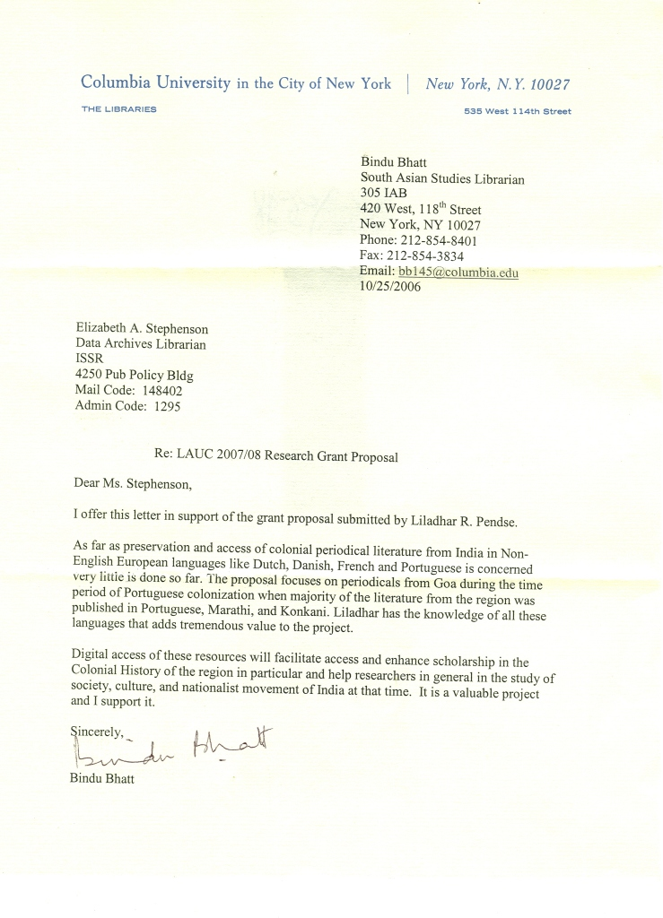
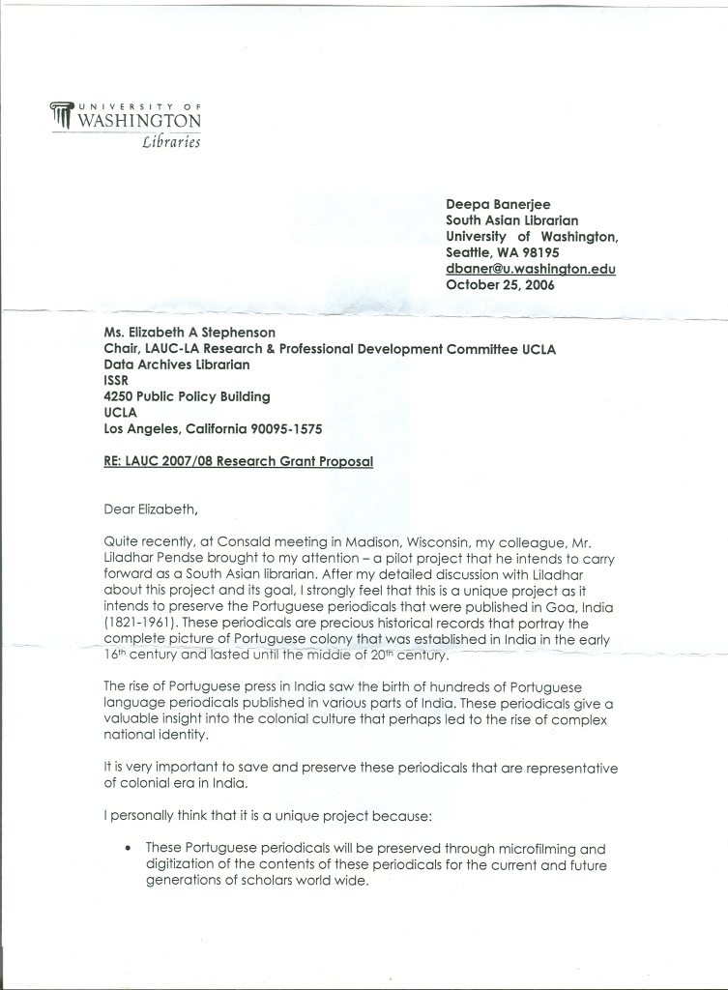

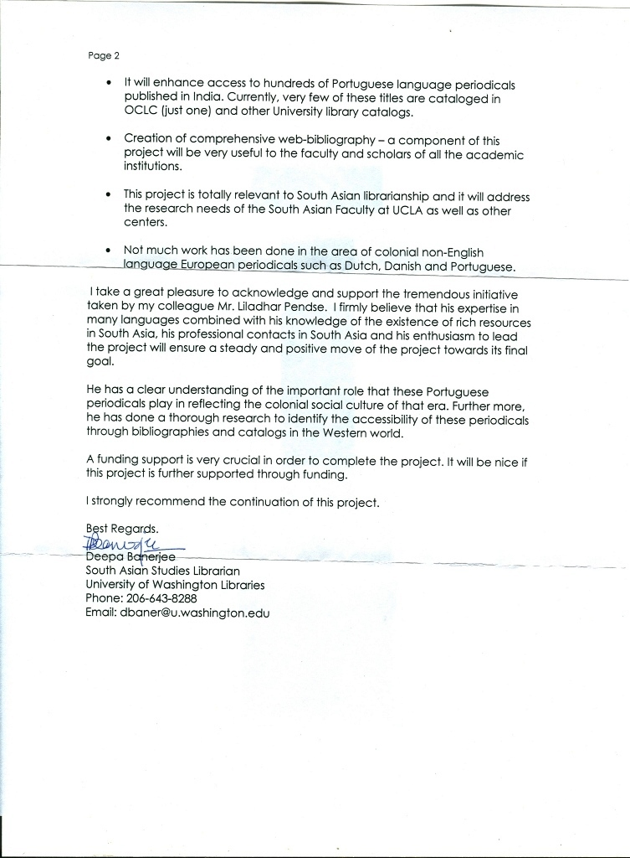
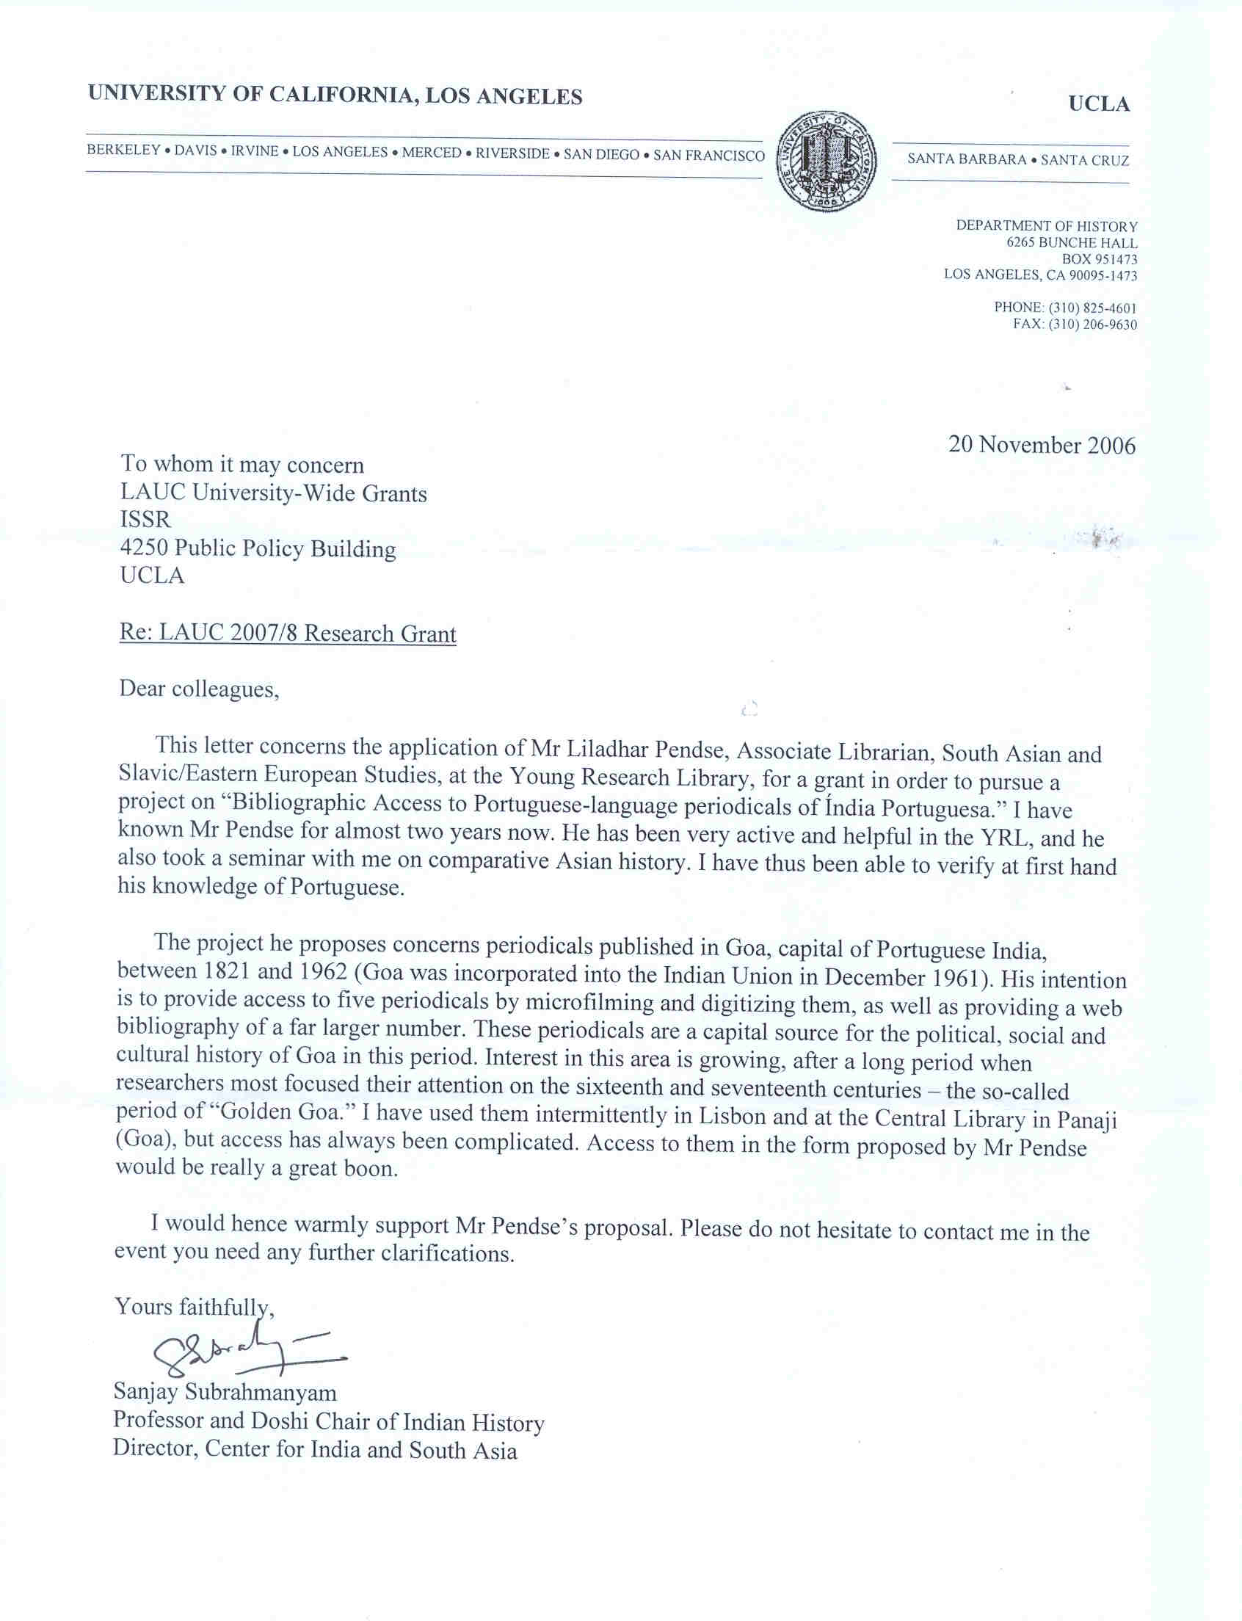
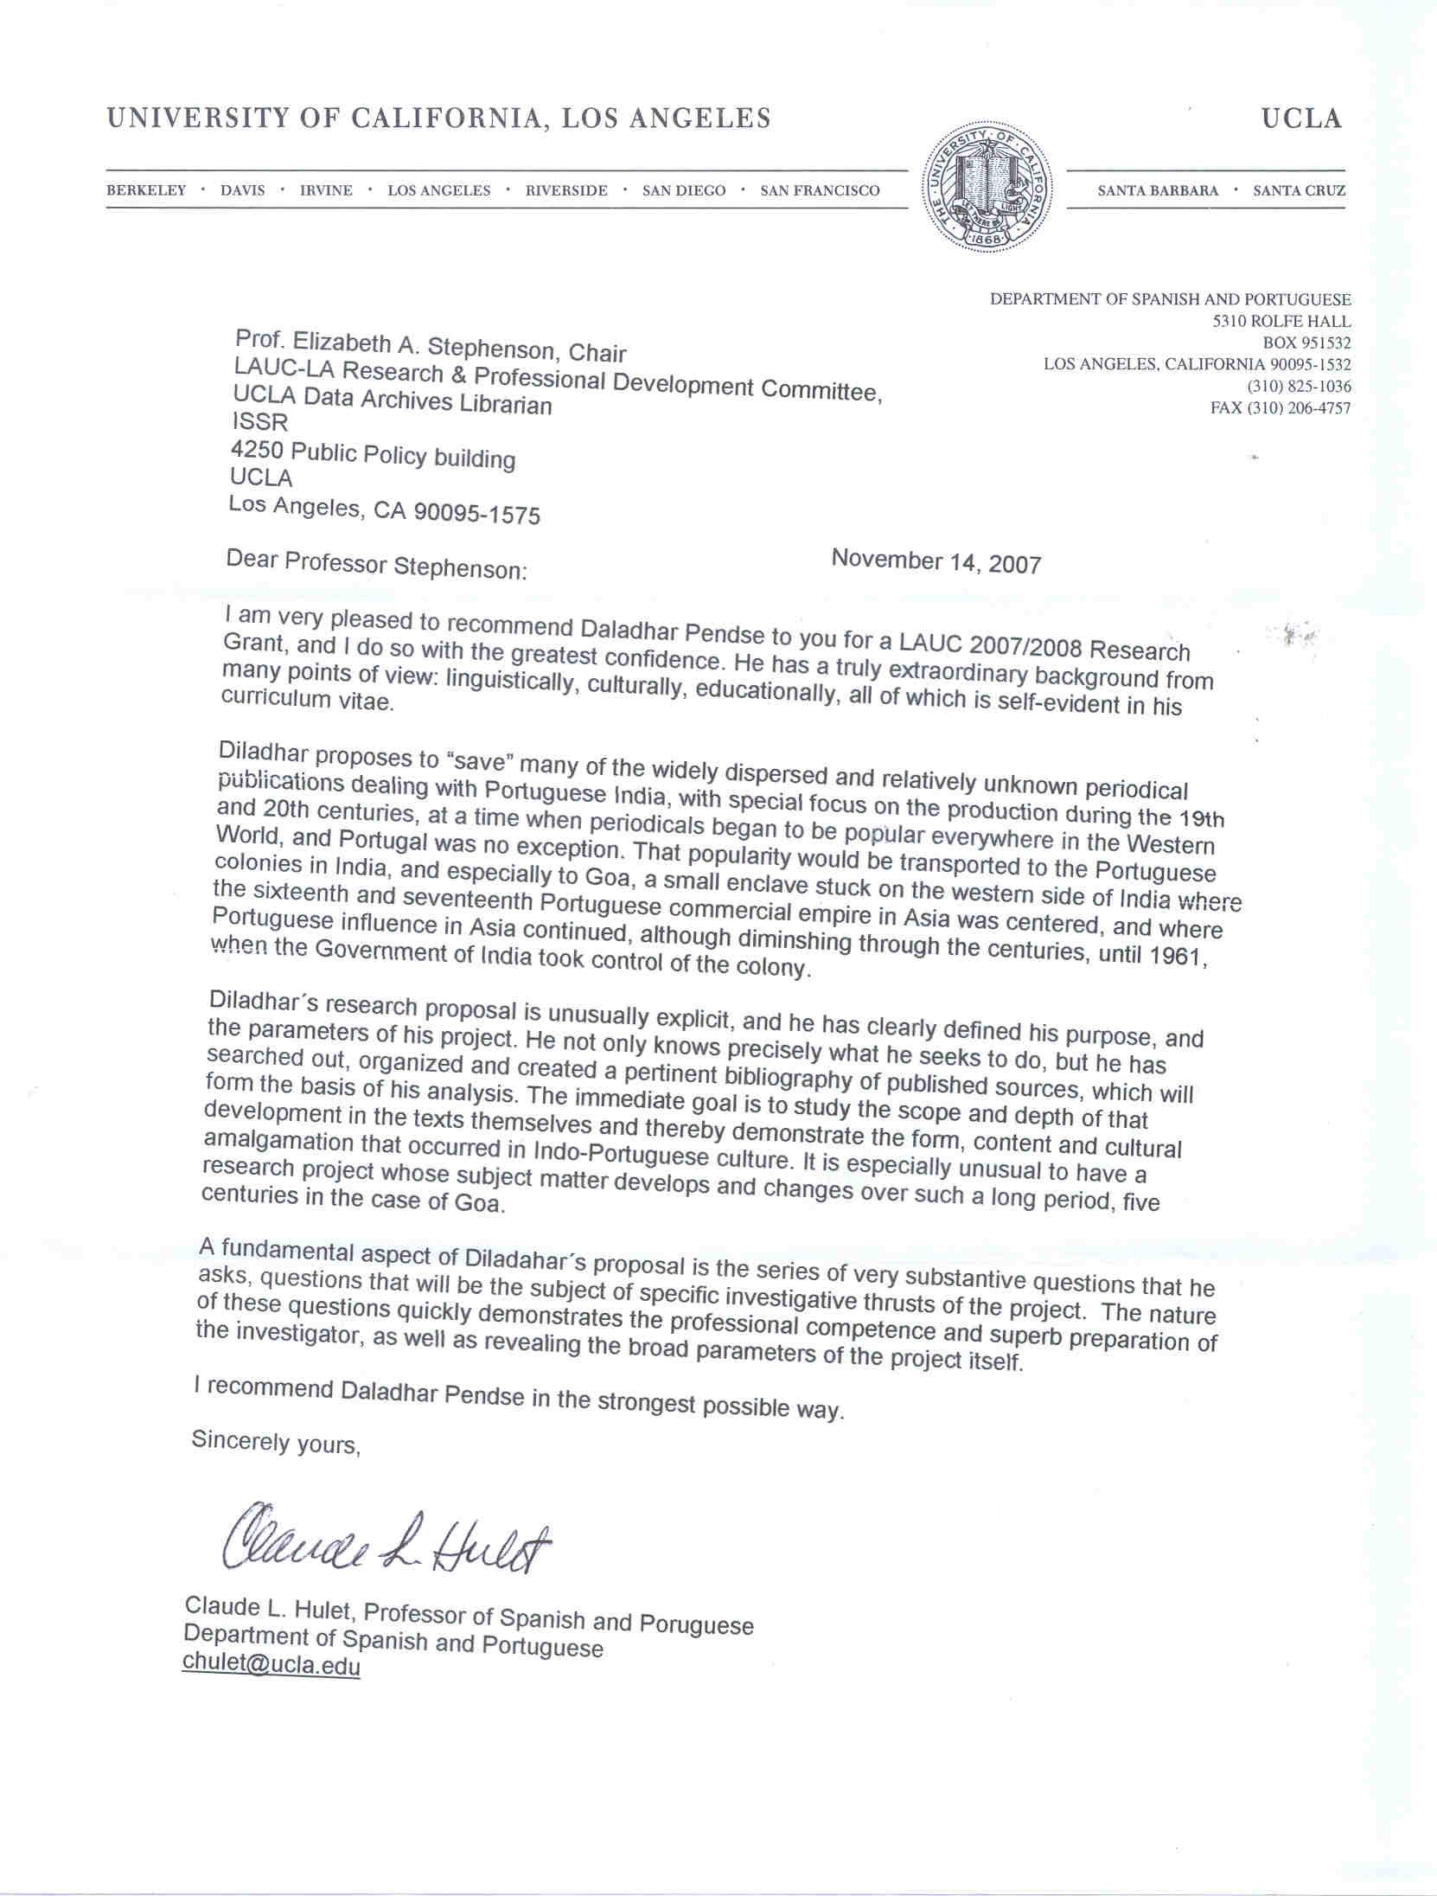

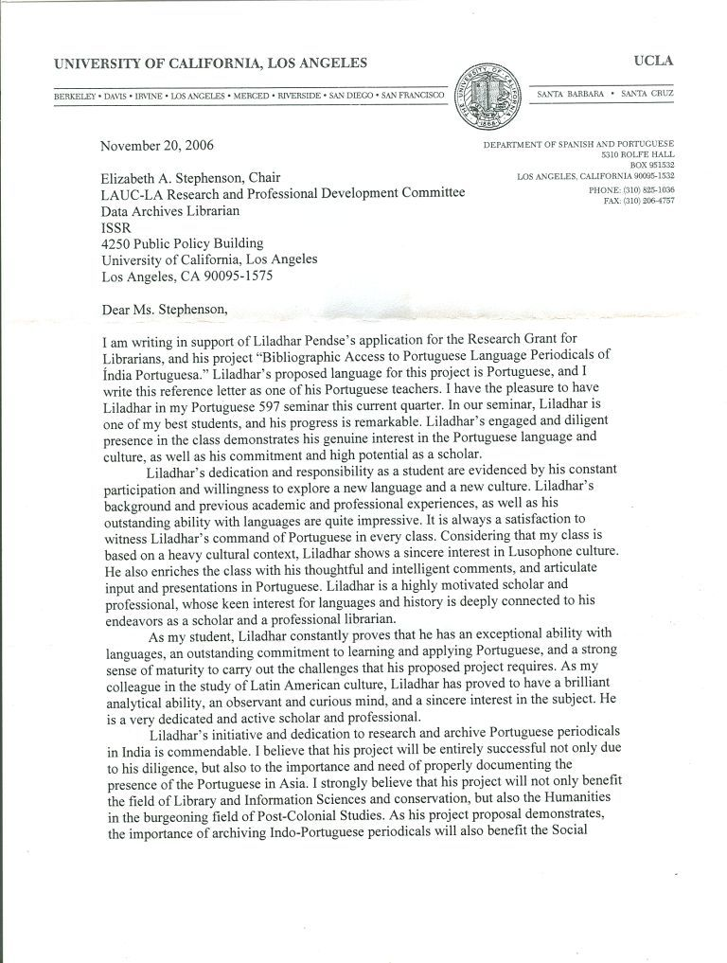
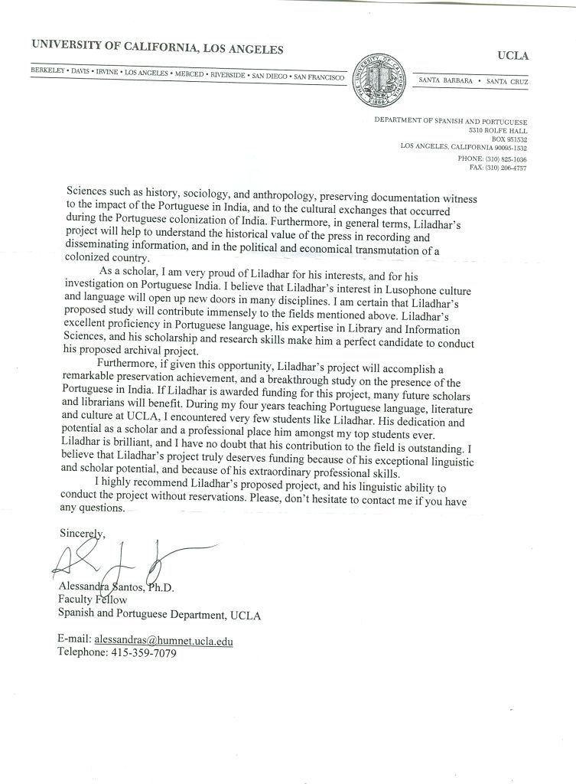
Appendix IV
Kati Radics’ Signed Permission
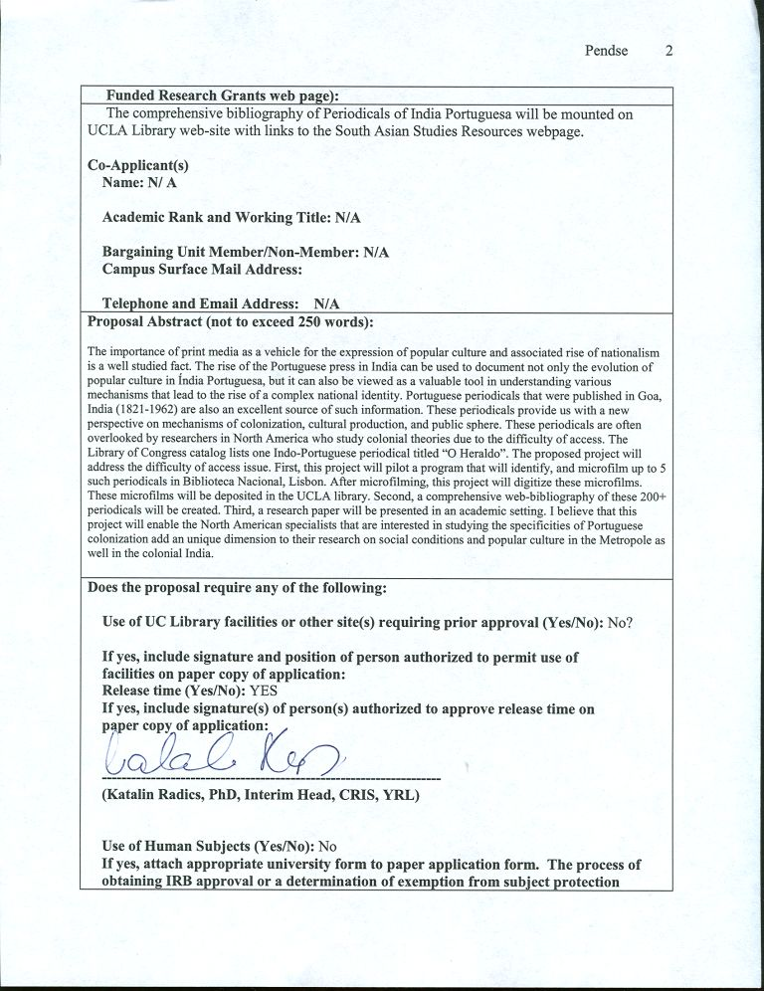
Appendix V
Excel Table of Indo-Portuguese Periodicals

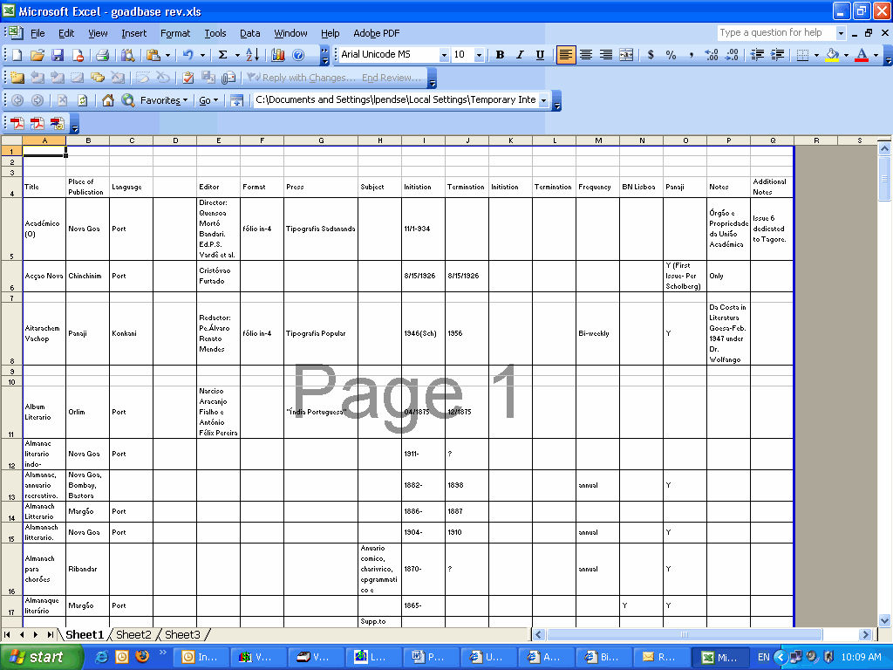

Appendix VI
Screenshots of Web-based Bibliography that was created using the Access Database

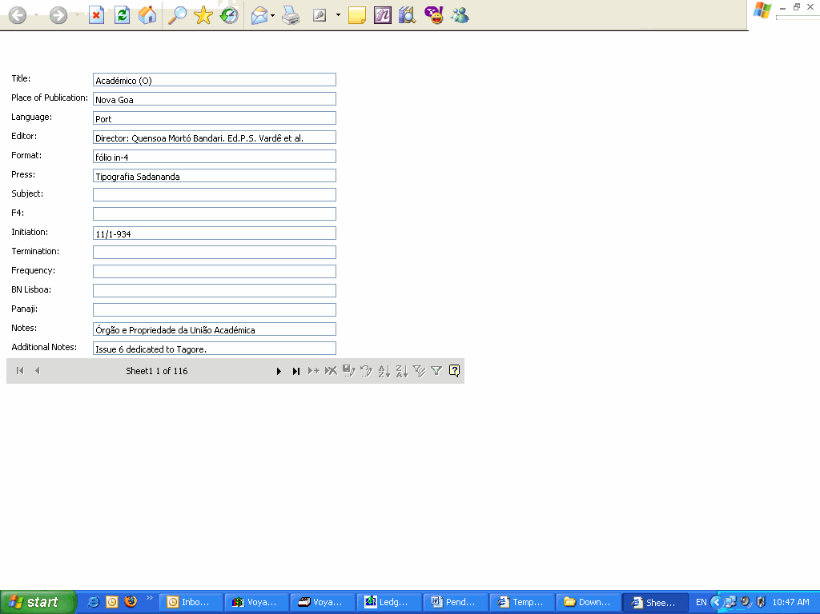

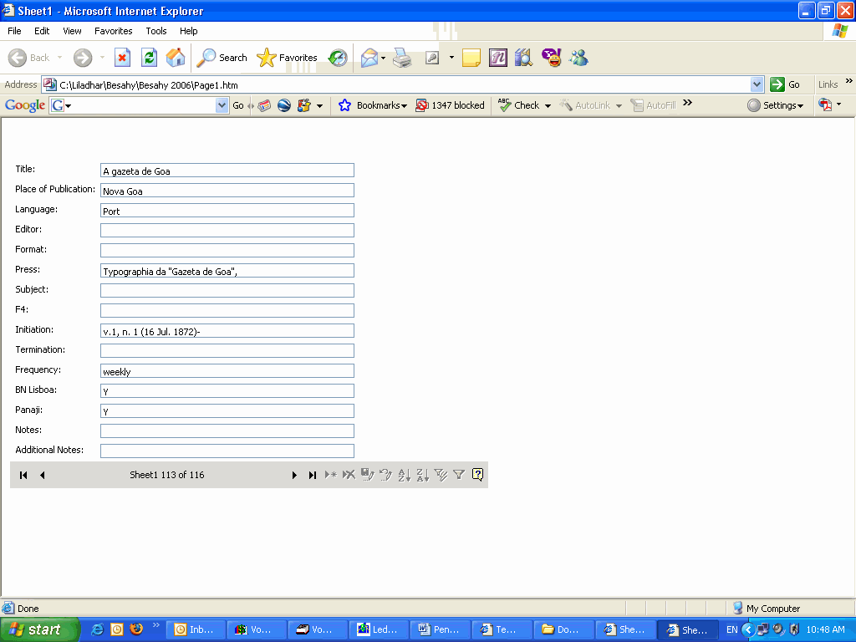

Benson Rodney and Neveu Eric,Bourdieu and the journalistic field, Cambridge, MA 2005.

