LAUC Diversity Committee Report 2012-2013
Submitted by Matt Conner, Chair
on behalf of the LAUC Diversity Committee
Executive Summary:
The Diversity Committee had a three part charge: (1) Analyze the results of a LAUC membership survey on diversity in 2011. (2) Design, administer, and analyze a new survey in 2013 and compare its results with the previous one. (3) Compare both results to regional and national data. The study found that in terms of absolute numbers the LAUC membership is quite undiverse with a profile that is heavily white, female, older, relatively senior in rank, all consistent with longstanding norms of the library profession. However, the LAUC results appear more favorably in comparison to other groups. Along with other academic libraries, LAUC compares favorably to measures of diversity for both public and special libraries. And along with other libraries on the East and West coasts, UC does better than libraries in the interior. Among all types of libraries, LAUC is positioned as favorably as possible in the face of challenges to funding and staffing that loom in the future for the profession. The report will be divided into three parts that reflect the committee's charge.
Part 1: 2011 Membership Survey
This section analyzes the LAUC survey of 2011. The survey was undertaken as part of a re-evaluation of the staffing of libraries as the profession undergoes change. A number of issues demand attention such as the aging of the staff with the prospect of future shortages, the training of staff, and the diversity of staff. The definition of “diversity” is a complex matter. A survey that fails to recognize all the relevant categories runs the risk of silencing them and perpetuating the discrimination that it is trying to avoid. The survey used basic categories of race, gender, and ethnicity as well as some derivatives of interest. The results indicate that the LAUC membership is not diverse in any sense of the word. The profile is overwhelmingly white, female, full-time, relatively senior in age and rank, heterosexual and without disabilities.
Results
The response rate was hugely successful with 346 respondents of whom 328 or 94.8% completed the survey. The number of respondents is relative to the total number eligible for the survey, and that number is still unclear. A rough estimate would suggest that the librarians in the 10 UC campuses cannot number more than 500 in which case the response rate is well over 50% and well over the 20% that seems to be the norm in many similar UC library surveys. An approximate number of 424 was found by counting up the rosters of individual campuses. This would place the response rate at 82%.
The representation of the campuses in the survey (Question 1) is proportional to their sizes.
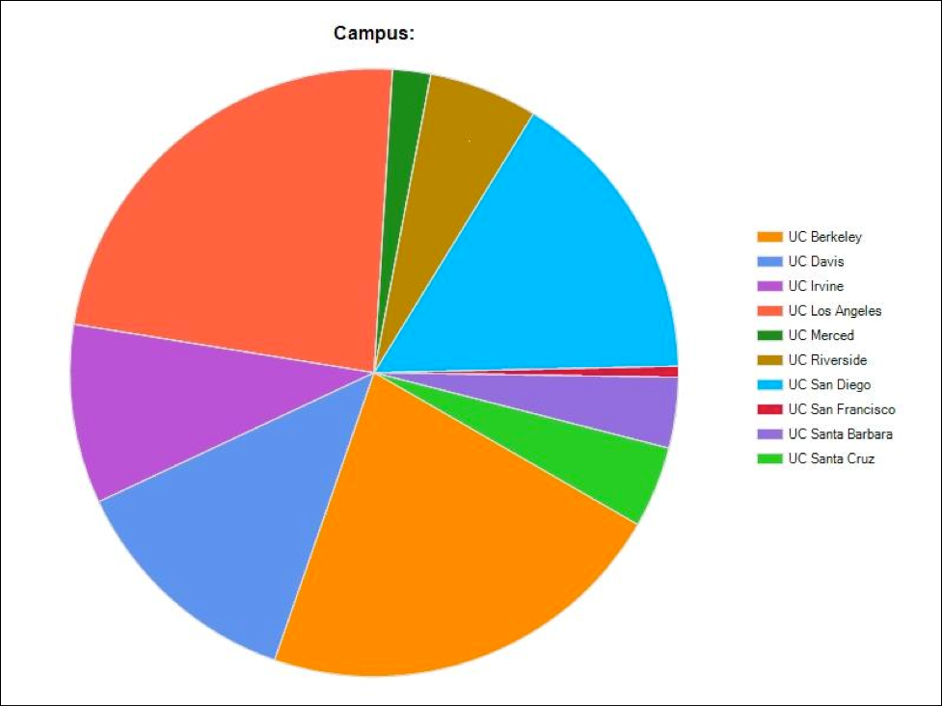
(Figure 1)
UC Berkeley, UCLA, and UC San Diego, the largest campuses, have the largest number of respondents. Only a count of number of respondents for each campus compared to the campus roster can show how well each campus was represented, but one can assume no campus is neglected in the results.
Rank data (Question 2) indicates that librarians are concentrated in the senior rank (Librarian) with the largest category, Librarian III, with 11.6% of respondents. The numbers diminish in a linear way as the ranks decrease from Librarian V to lower ranks.
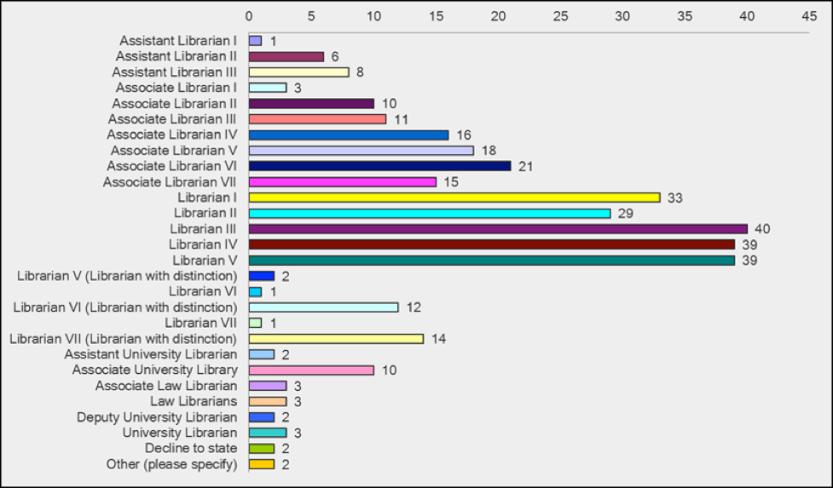
(Figure 2)
Duration of work (Question 3), somewhat surprisingly, indicates that the bulk of librarians have worked on the shorter end of the scale.
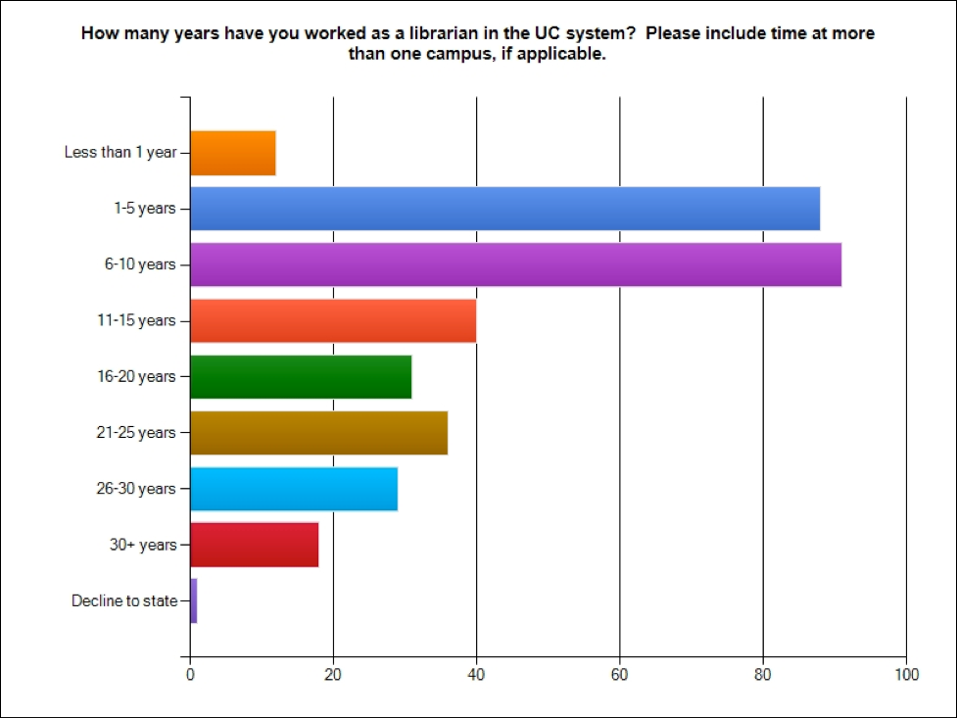
(Figure 3)
Job status (Question 4) is overwhelmingly full-time at 91.3% as opposed to any part-time or temporary positions.
Age (Question 5) shows that numbers increase steadily as age increases.
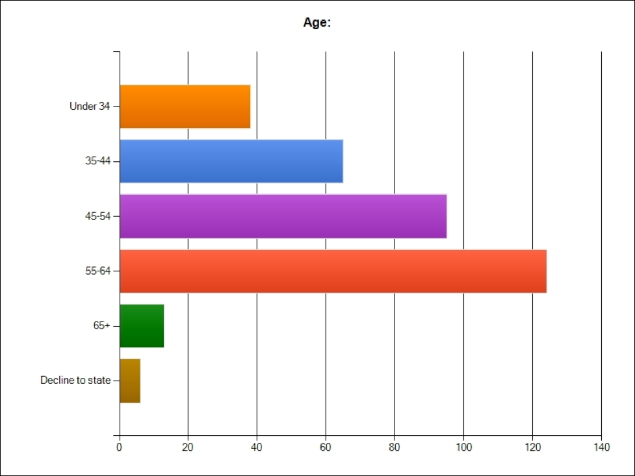
(Figure 4)
Race (Question 6) is overwhelmingly white at 72.4%. The second largest category is Asian/Pacific Islander at 10.3%. Possible reasons for this disparity are that, first, more white people may have joined the librarian workforce years ago when affirmative action was not enforced as well as it is now. Now we are getting more diversified employees, such as three new librarians who joined UCR Libraries in 2012 (1 white and 2 non-white). As more whites enter the retirement phase, their representation is expected to decline. Gender (Question 7) showed a majority of females at over 2:1 with 70.7% and 27.3% for males. Sexual orientation (Question 8) was overwhelmingly heterosexual at 75.1% and the next largest category of gay was at 6.2%. There were vigorous objections in the comments to this question as an invasion of privacy. Highest degree earned (Question 9) is the MLIS far above all others at 62.3%, and the next highest category is a second master’s in addition to the MLIS at 24.6%.
Language skill (Question 10) surveyed members for their speaking, reading, writing, and comprehension skills and produced complex results.
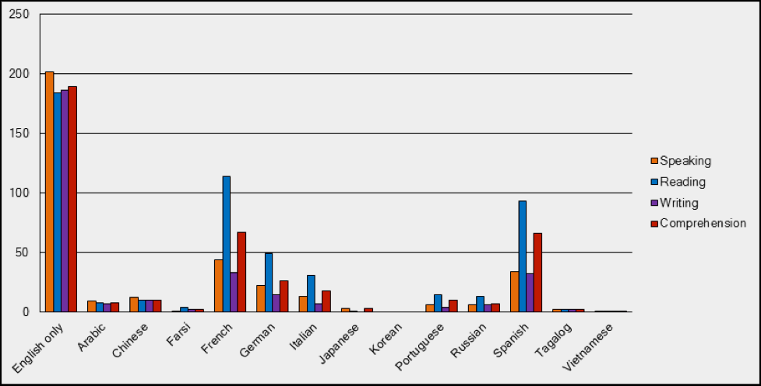
(Figure 5)
Clearly English is far more common than other languages with the major European languages—French, German, Italian—at about half the number of English. A more detailed analysis of the results can reveal which languages appear to be associated with cataloging skill as opposed to ethnic diversity.
Disability status (Question 11) indicates that respondents overwhelmingly (90.6%) do not have disabilities.
Cross-Correlations
A significant feature of diversity analysis is to examine not only the representation of different categories but correlations between them to explore possible discrimination. Are women underrepresented in their earnings? Do whites have a disproportionately higher share of senior positions? The number of possible correlations among the variables is vast. The committee considered the following.
Race vs. Rank
First, the distribution of race shows an overwhelming number of whites.
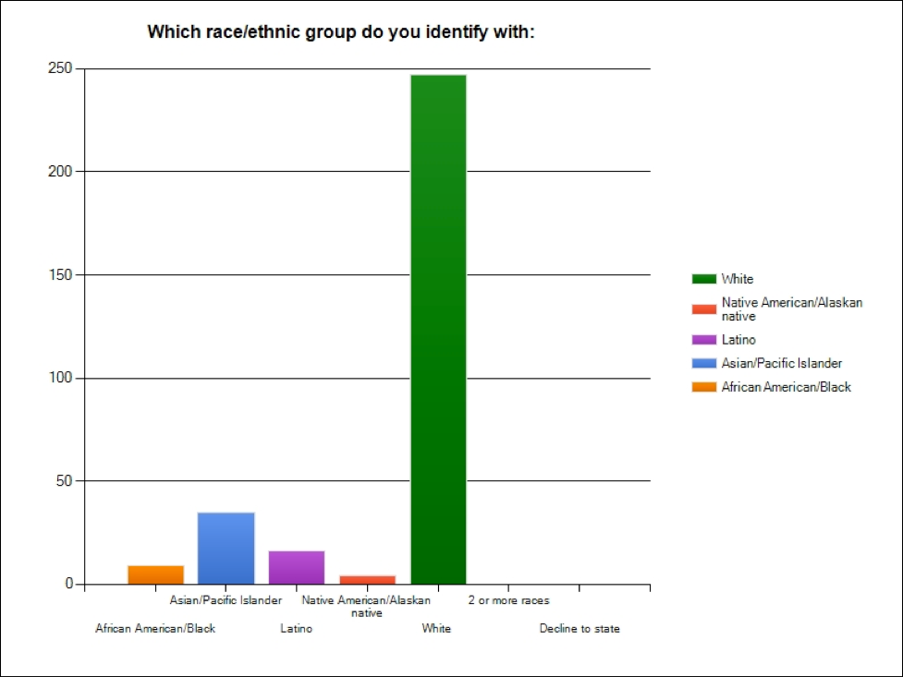
(Figure 6)
The correlation of race against rank is as follows.
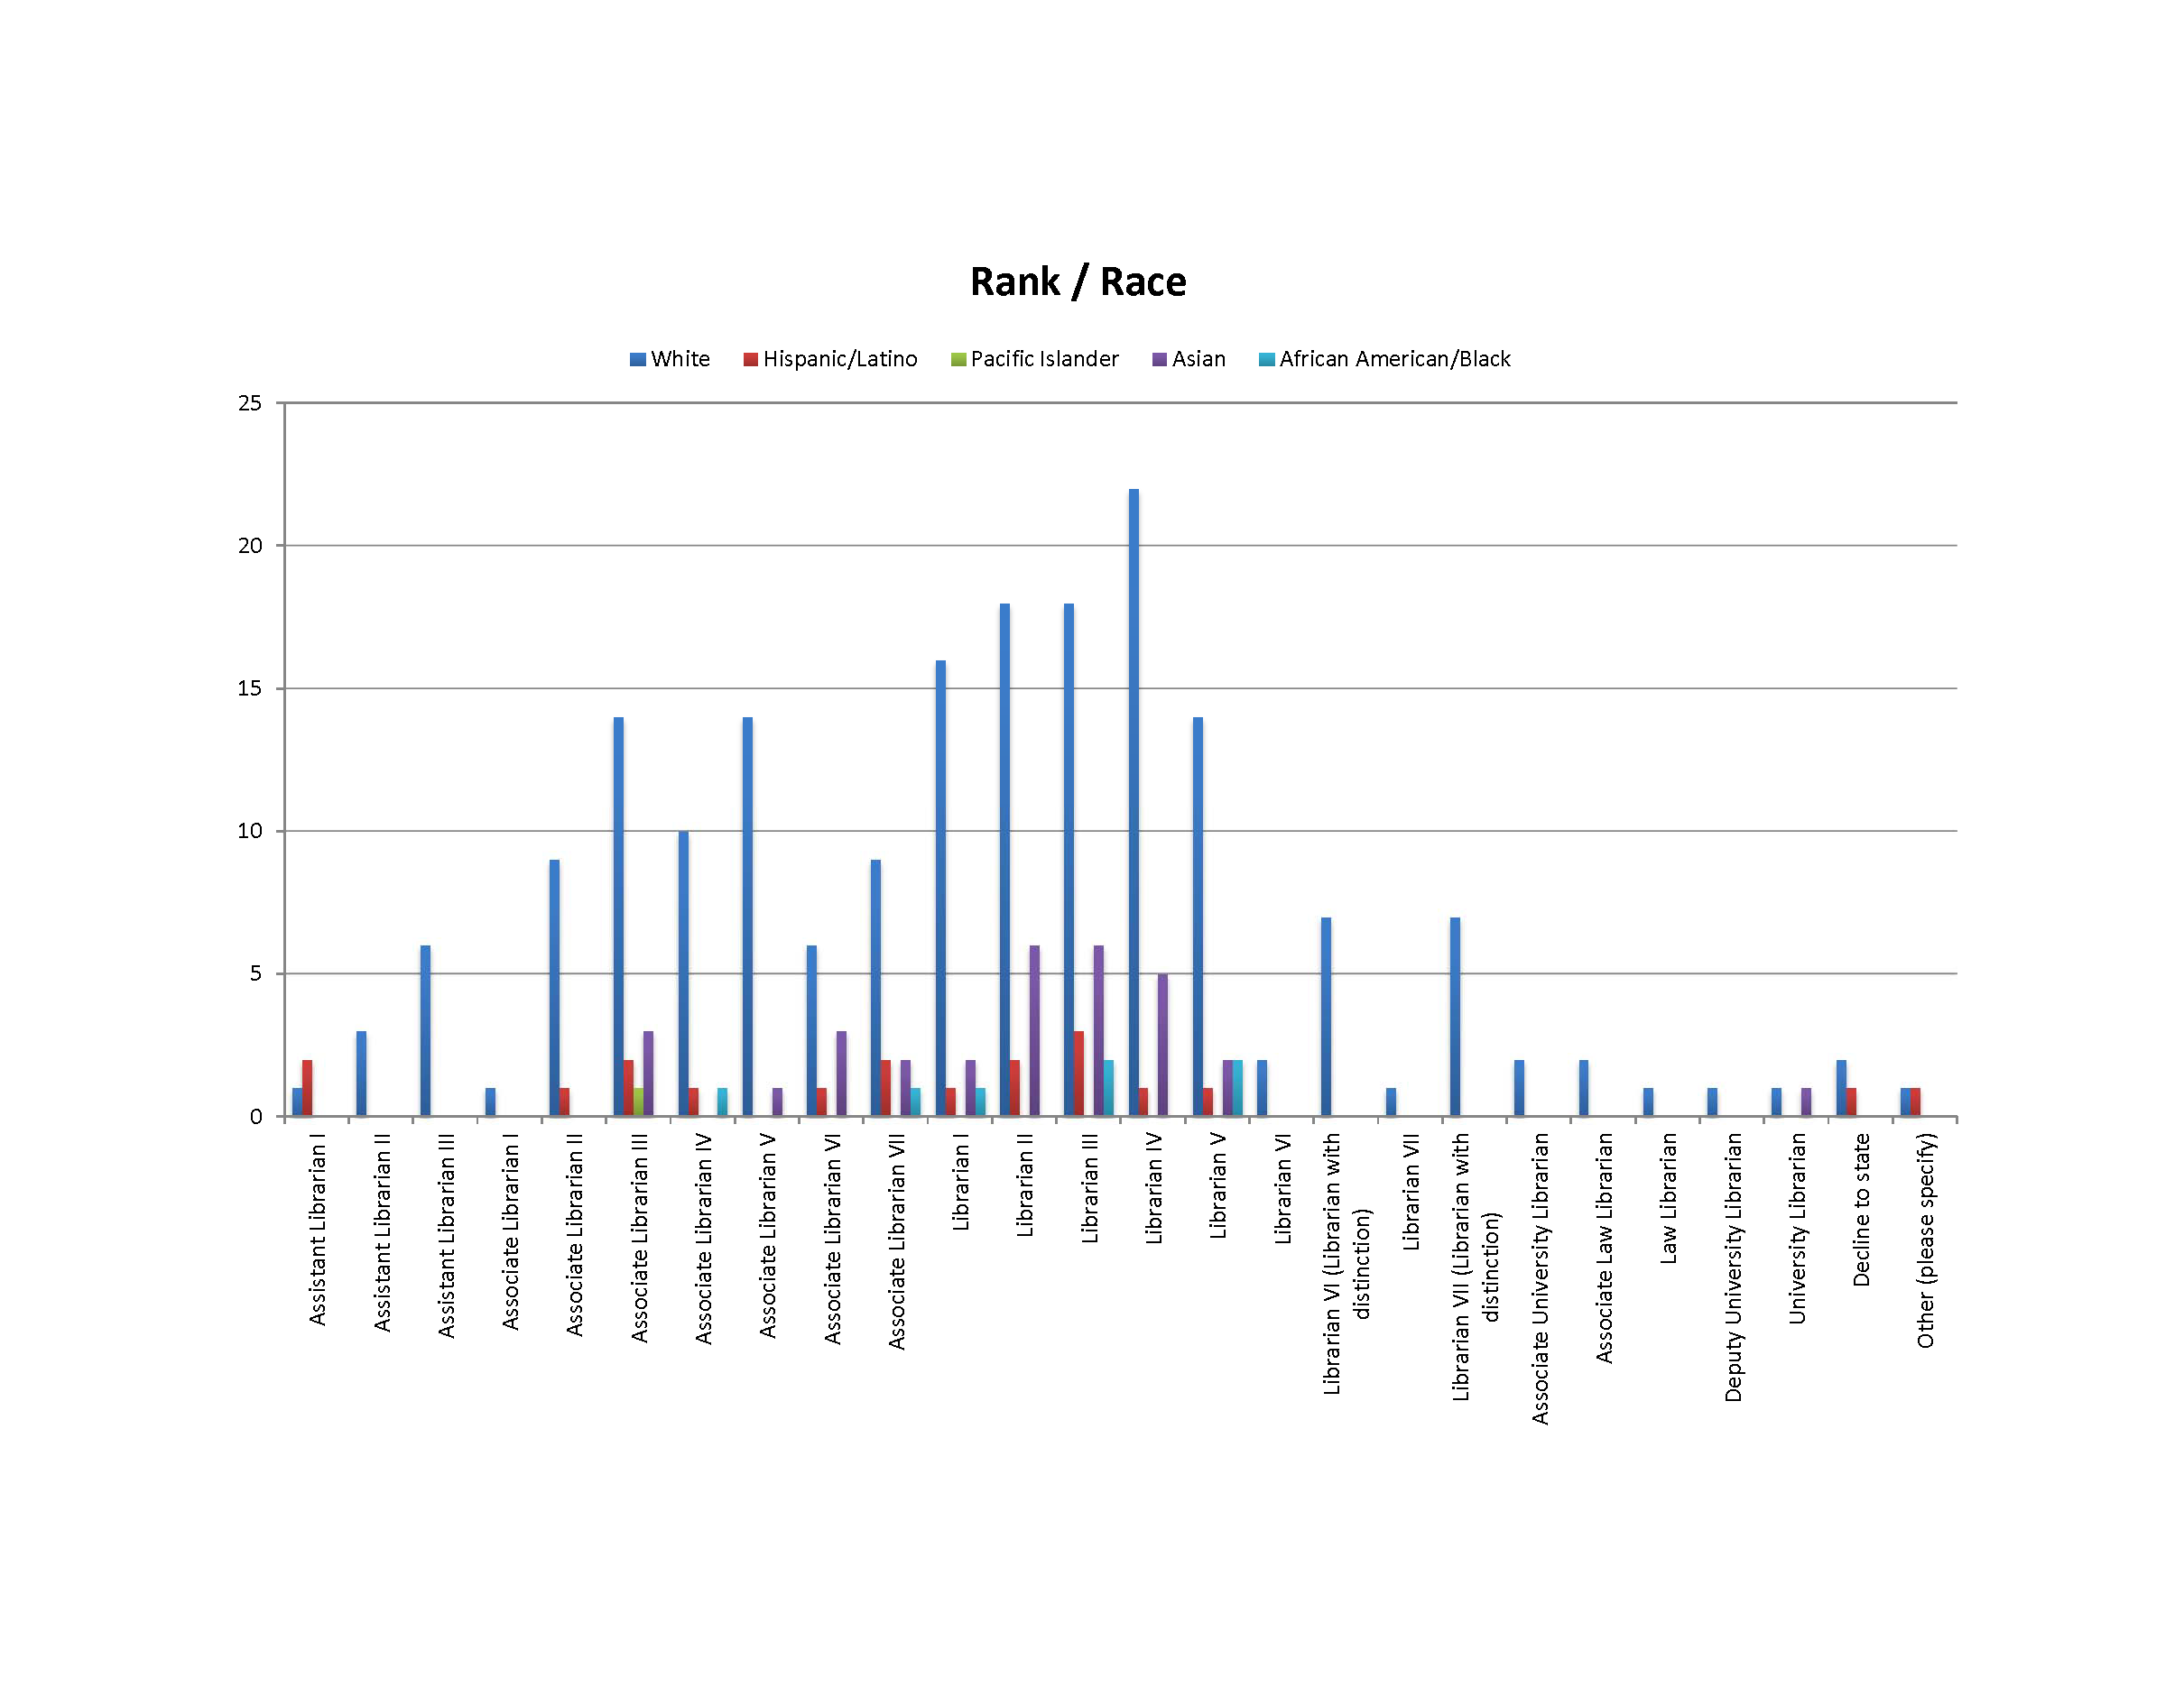
(Figure 7)

The number of whites exceeds other ethnic groups for all ranks as shown in the preceding figure. To distinguish the cross-correlation effect from the absolute number, one looks at the rate of change of the different ethnicities across ranks. There are more whites at the librarian ranks than associate ranks, but this is also true of minorities. So, the difference between ethnicities across ranks remains more or less constant to a rough approximation. There is no indication that whites are being overrepresented at the senior ranks.
Gender vs. Rank
Below is the correlation chart for gender and rank.
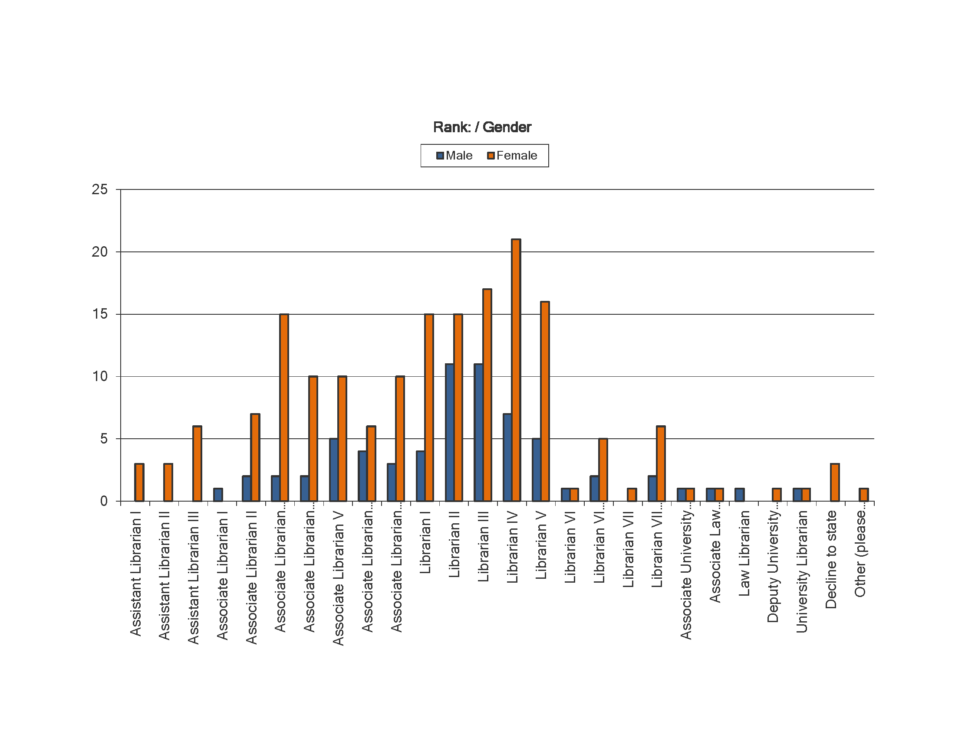
(Figure 8)
As before, one looks for the rate of change between the variables (male and female) across rank. There is little change. If anything, the number of females increases relative to males at the higher ranks. Librarian IV (33:6), Librarian V (27:11) and Librarian VI with distinction (9:3). One might construe this as reverse discrimination against males. However, this is implausible and cannot be verified without a statistical analysis of significance. It seems safer to assume that this is statistical noise and that rank has no significant correlation with gender representation.
Discussion
The data bears out the general profile of the LAUC membership as heavily female, white, relatively senior in age and rank, heterosexual and without disabilities. The data also underscores the concerns about a relatively older workforce that is not replacing itself which could lead to a shortage of librarians and which, at a large enough scale, could threaten the profession as a whole.
The only anomaly with the data is that while the senior ranks are heavily represented, the time worked was relatively less than expected. The 1-5 and 6-10 year categories has the largest numbers. This does not seem to be enough time to achieve senior rank in the profession. Speculations about the reasons for this supported completely opposite conclusions. Perhaps we are not retaining senior ranks who are coming and going at a rapid rate. Or alternatively, perhaps it is the senior ranks that are static and we are not retaining the lower ranks who are not staying at UC in preference to other opportunities. Perhaps the simplest explanation is the recent policy measures taken in response to the budget crisis of 2008. Hiring freezes prevented the acquisition of new librarians. Retirement incentives encouraged the retirement of the most senior staff. Both policies would tend to increase numbers in the middle range of the profession in terms of time and rank which is, roughly, what we see here.

Part 2: LAUC Membership Survey 2013
The 2013 survey continued the original plan of the LAUC Diversity Committee to generate longitudinal data on the LAUC membership. This survey is the second in a series that began with the survey in 2011. The new survey repeated the essence of the old questions. Based on survey feedback, some of the questions were modified, and new questions were added. The new survey at 20 questions is approximately twice the length of the old. The survey was administered through SurveyMonkey as before and sent to all 10 campuses of the University of California (UC) through a link that was distributed by members of the LAUC Diversity Committee to their divisions.
Response
The 2013 survey was started by 247 respondents and completed by 193. Based on a count of individual campus rosters, the total LAUC membership has been approximated at 424. This would give a response rate (percent of total membership who started the survey) of 58%. The completion rate (percent of those starting who finished) is 78.1% Both figures are noticeably lower than for the 2011 survey which are an 82% response rate and a 95% completion rate. One ready explanation for the drop in numbers is that the new survey was twice as long, although it must also be observed that the survey was not particularly difficult and took about 15 minutes to complete. Committee members also observed anecdotally that the lower participation may reflect survey burnout as a result of the extensive reassessment done throughout UC. In any case, the numbers appear large enough for at least roughly representative data.
Question 1
Campus representation. The results are virtually identical to a similar question from the previous survey. The three largest campuses, Berkeley, UCLA, and San Diego have the three highest numbers of participation. This is consistent with a representative response of the membership, and it argues against an unrepresentative response. For the proportion of respondents from each campus to vary wildly while the differences between campuses remain proportionate to their size is implausible. In combination with the solid response and completion rates of the survey there is good reason to suppose that the survey results are representative.
Question 2
Rank. The answers to this question, not surprisingly, are virtually identical to the previous results with the bulk (approximately) half the respondents in the lower grades of the Librarian series—steps I through V.
Question 3
Salary. This was a new question. 85% of respondents are in the middle range with salaries from $45,000 to $100,000.
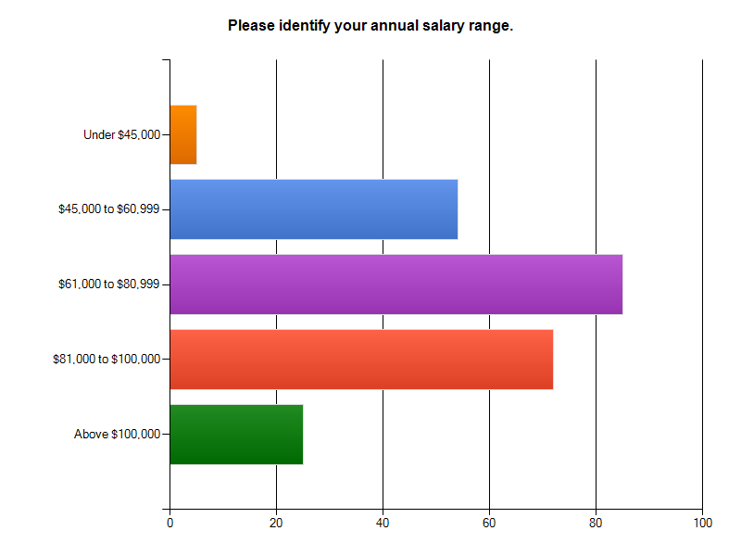
(Figure 9)
The middle category within this subset, of $60,000 to $90,000, has the largest representation of over 35%. These salaries are consistent with the lower levels of the librarian series which are most heavily represented.
Question 4
Years worked. Results here are identical to results for the same question in the previous survey. The most heavily represented categories are the earliest from 0 to 15 years worked which accounts for approximately 70% of respondents.
Question 5
Years worked in another information profession besides librarianship. This is a new question. The bulk of the responses are for the early categories from 0 to 15 years worked which accounted for about 53% or a little over half of the respondents. It was noted that many of the written responses for the Other category indicated that they had never worked for another profession which seemed different from the lowest category of Less than 1 Year. This should be clarified in future surveys. It was pointed out that these responses of 0 years worked should be added to the first category, but that would only move 2.4% to a new category and would not affect the larger trends of the results. The trivial explanation for the bulk of responses at the lower end of the scale is that individuals who had worked for long periods in other information professions would likely not have switched careers to librarianship and would not be in a position to answer this question. Otherwise, the picture of mobile individuals moving between librarianship and other information professions is consistent with national trends about competition for library staff which will be discussed later in the report.

Question 6
Management responsibilities. This is a new question. Slightly less than half of the respondents (44.5%) claimed management roles. It was noted by the committee that the question does not distinguish between supervision of library staff and student employees, a point also made in the survey comments. It was thought that this distinction might be important and should be made for future surveys. However, the supervisory experience of leading and interacting with different personalities is captured by this question. Approximately half of the responses reporting management positions is higher than one is led to expect from national data about the desire for more management responsibility. This will be discussed further below.
Question 7
Status of position. This question reproduces the results from the previous survey that an overwhelming number of staff—almost 90%--have full-time positions.
Question 8
Age. This question reproduced the results of the same question on the previous survey. Age is weighted towards the higher end with categories gaining more responses up to 55-64, the largest category with 34% of respondents. This is consistent with the relatively high rank of the bulk of respondents.
Question 9
Race. Whites are even more predominant than for the last survey moving up from 72.4% of the total to 77%. As suggested through feedback, the category of Asian-Pacific Islander was separated into different categories for Asian and Pacific Islander and the results for the two are markedly different. Asians are the second most numerous group at 12.7% while Pacific Islanders make up 0.4%. The old combined category was 10.3% of the total. Asians are about equivalent to Hispanics in the new survey. Differences from the previous totals are small enough that they can be attributed to variation in response rate as opposed to actual demographic changes.
Question 10
Gender. The disparity in genders has increased slightly with women more than men by greater than 2:1 which was the figure from the last survey.
Question 11
Sexual Orientation. Heterosexuals remained overwhelmingly prevalent and actually increased to 80% of the total up from 75.1% from last time.

Question 12
Religion. This is a new question. The largest category is “Not religious” at 44%. There was some discussion on the committee whether that figure should be merged with the category “Atheist,” the third largest at 9.9%. One comment argued that as a rejection of religion, “Atheist” should not even be represented as a category. But the committee sentiment prevailed in merging “Not religious,” which could also include agnostics identified in the comments, with “Atheist” as various forms of divergence from religion. Among recognized religions, Christianity is most heavily represented at 19.3%. There are small numbers of other religions with Islam the smallest at 0.4%.
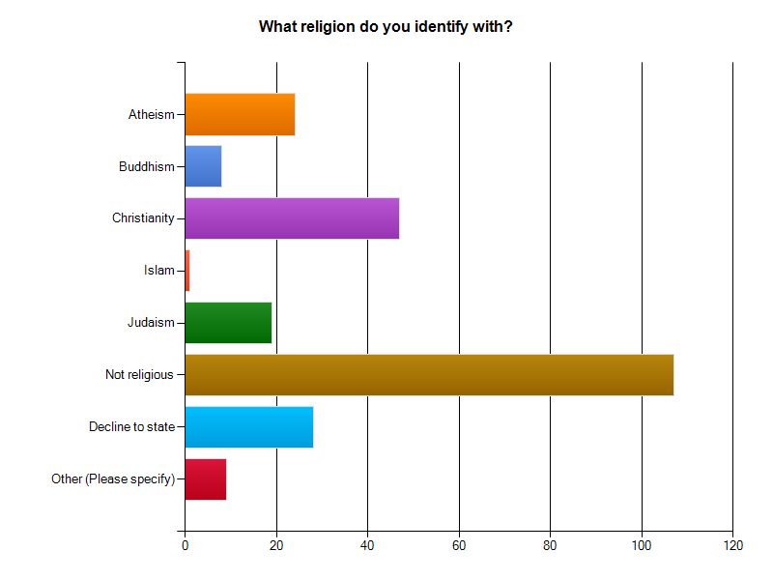
(Figure 10)
The non-religious responses are interpreted to represent the liberal-secular views of the Academy. The relative popularity of Christianity among the recognized religions is attributed to the historical/cultural tradition of the United States as a Judeo-Christian nation. In both cases, the library appears representative of its larger communities with no sign of specific discrimination.
Question 13
Degrees earned. The results of this question repeat those of the earlier survey with an overwhelming number of MLIS degrees reported. The second largest category of second subject master’s (28.7%) held steady at approximately the same proportion as before. The committee noted ambiguity in the question about whether the second master’s had to be in the same subject area where the librarian was working. This should be clarified in future but it is unlikely to change the trends here. There are negligible amounts of other degrees. The status of the second master’s speaks to the demand for this degree in the librarian job market; the competition for librarians from other fields; the tendency of librarians to move between careers; and the need for librarians to increase their versatility by cross-training.
Question 14
Location of degree-granting institution. This is a new question aimed at assessing geographical diversity. Approximately half (46.7%) are from California; the rest outside. The majority from California is not a surprise given the size of the state, the desirability of living here, and local inertia that appears in most job locations. It is perhaps more surprising that the out-of-state number is as high as it is. Moreover, a first scan of results indicates that the largest number of degrees in the out-of-state category is from as far away as New York. Perhaps one can discern a coastal culture operating here. The results are reported for individual states. Further analysis might group the out-of-state locations into broad geographic regions for the two coasts and the middle section to investigate their relationships.
Question 15
Undergraduate major. This is a new question designed to get at the type of preparation that librarians have. The highest categories by far are humanities and social science at 46.7% and 24.6% respectively. Combined with the arts at 11.9%, these numbers indicate that approximately 85% of undergraduate majors are non-scientific.
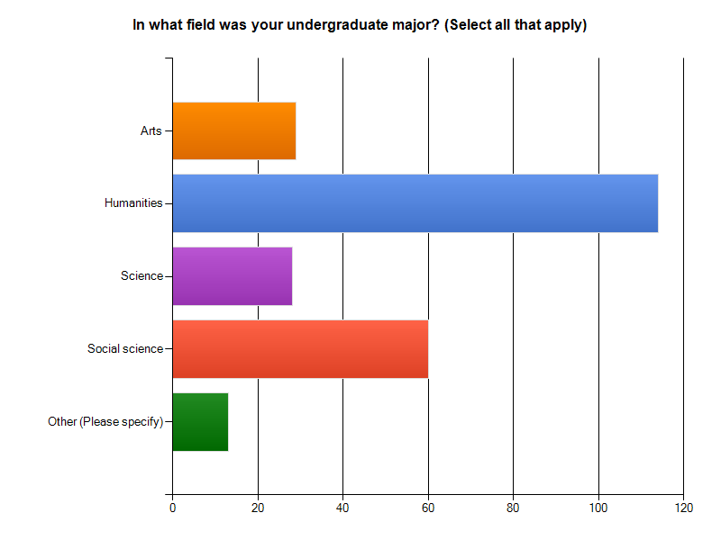
(Figure 11)
This is a little surprising and unsettling. It suggests a significant lack of diversity in training in the sciences and a lack of preparation for the technologies that look to be so central to the future of librarianship.
Question 16
First career. This is a new question designed to take another look at the movement of librarians between different professions. A slight majority, 59%, indicated that librarianship is a first career. For approximately half to have worked in another career is consistent with the picture of mobile staff able and willing to change jobs.
Question 17
Non-English speakers. This question was designed to give an overview of the complex data of language skills by making a simple division between English and other language speakers. Results indicate that slightly more than half, 52.9% speak another language besides English. At the least, this would indicate that a second language ability is not a rare thing.
Question 18
Language skills. The results are similar to those for the last survey. English predominates. The occurrence of other languages falls off dramatically from there. Levels of speaking, reading, and writing introduced a degree of complexity and variation into the graphs without altering the basic profile.
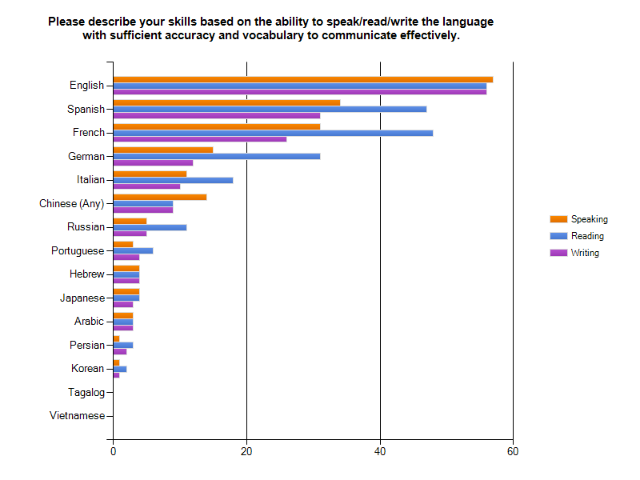
(Figure 12)
The relatively larger representation of the European languages compared to the earlier survey was explained by the fact that the preceding question, number 17, routed English-only speakers past this question on to the next one. Therefore, the higher proportion of European languages compared to English does not show an increase in occurrence of European languages but a decrease in the occurrence of English-only due to a change in survey design. A number of comments stated a proficiency in Latin, which was not represented in the survey, but these totals would not have materially changed the question results.

Question 19
Disability. This repeats a question from the previous survey. As before, an overwhelming proportion (87.8%) report no disabilities that impact their work.
Question 20
First generation college. This is a new question inquiring about the proportion of respondents who are first-generation college. It is designed to explore the socioeconomic diversity of the membership as well the degree to which the library is drawing on new sources of staff in light of the coming shortage. 31.9% reported that they are first generation college. How to assess this number in the absence of reference points is not obvious. But it was pointed out that for one-third of the membership to be not only the first to earn a college degree but also a graduate degree (MLIS) is a significant achievement.
Question 21
Call for comments. Unlike the previous survey, the comments had virtually no criticisms of the questions. The earlier survey comments in many cases questioned the purpose of the survey or objected to intrusive questions. There is none of that here, and most of the comments are neutral observations about details of the survey or the profession. Such a change can be interpreted as an improvement in survey quality and can offset the relatively lower response and completion rates of this survey compared to the previous one.
Cross-correlation
Race vs. Rank
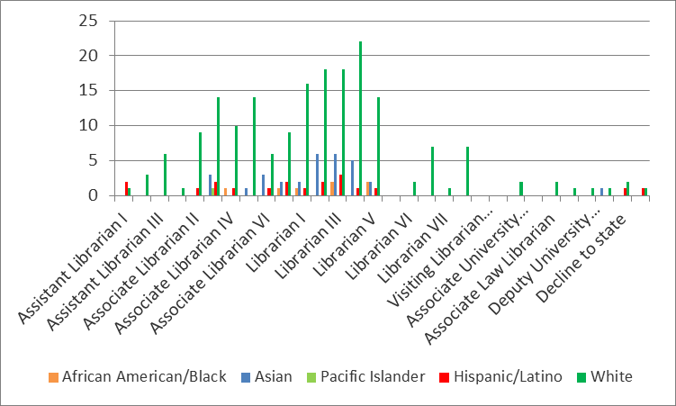
(Figure 13)
This cross-correlation repeats results from the previous survey. Whites predominant among racial groups, and the difference between them and other groups remains more or less constant between Associate and Librarian categories through all their subdivisions. While the number of whites increases as the ranks go up, so do the other groups. One concludes that there is no significant correlation between race and rank.
Gender vs. Rank

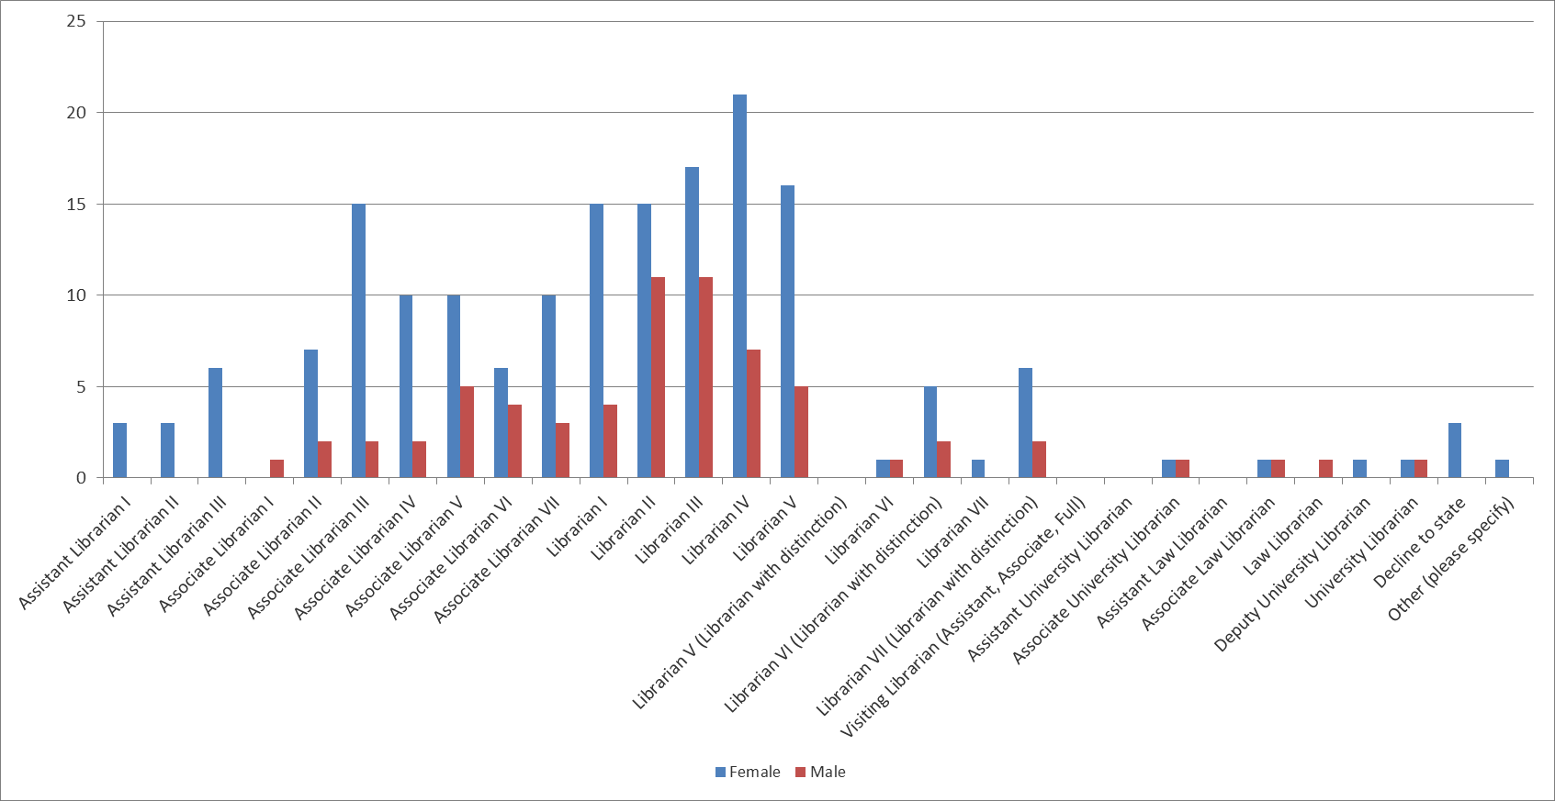
(Figure 14)
This cross-correlation repeats a comparison from the previous survey. As before, the difference between males and females remains roughly constant across rank indicating no significant correlation between gender and rank.
First Generation vs. Salary
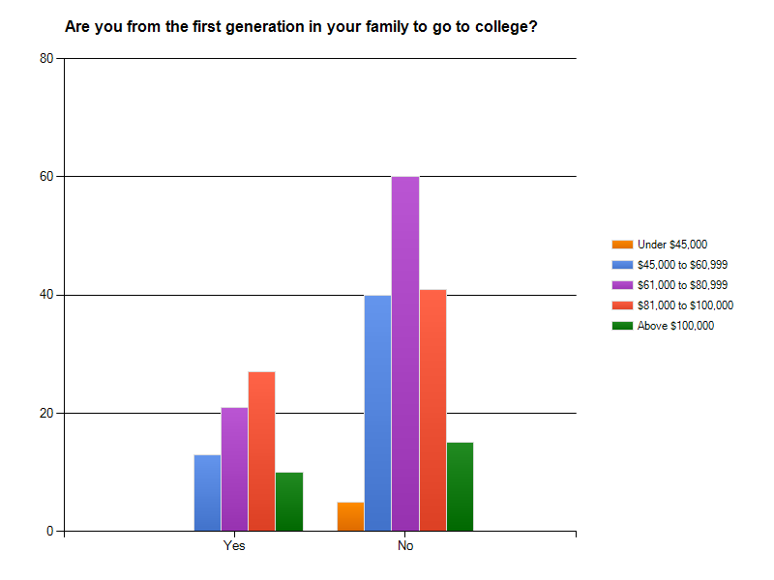
(Figure 15)
Here one does not compare the absolute height of the two clusters of bars. (The higher numbers in the “No” category just indicate the higher number of non-first generation college staff among respondents.) Instead one looks at the relative heights of the various colored bars within and between clusters. We have an unexpected result. One might suppose that those who are not first generation college, with a presumed advantage in affluence and experience in the educational system, would see that reflected in higher salaries than for first generation college staff without those advantages. Here one looks at the purple ($61,000 to $80,999) and the red-orange ($81,000 to $100,000), the two most numerous categories of salaries for both Yes and No clusters. One would expect the non-first generation staff (No category) to have higher salaries, but the proportion of these two colors is reversed from what is expected. The non-first generation has a higher number of the lower category ($61,000 to $80,999) and a lower number of the higher ($81,000 to $100,000) category. For the first generation staff, these proportions are reversed. The other categories of the extremely low and extremely high salaries for the two groups do not indicate any pattern. How to explain the strange reversal? The answers are not obvious. They certainly do not appear to reflect any form of discrimination against first-generation college graduates.
Degrees vs. First Career
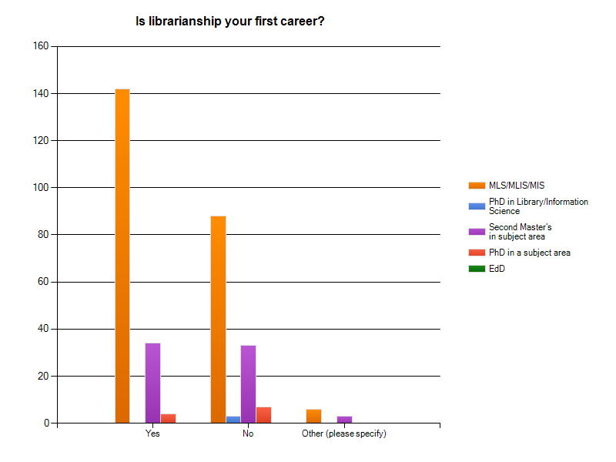
(Figure 16)
The supposition behind this cross-correlation was that the number of degrees would correlate with how many times librarians had switched careers to another field. This in turn would indirectly support the picture of a competition in the market for people with library-related skills and a related trend whereby librarians spend less time in their field because of career switches. The results seem to bear this out. While non-MLIS degrees are about equally represented for those for whom librarianship is a first career and for those for whom it is not, the number of MLIS degrees is way higher for 1st career librarians. This implies that for this category non-MLIS degrees are proportionately smaller. One concludes that the proportion of non-MLIS degrees correlates with librarians having other careers.
Discussion
In part, the 2013 survey reproduced the 2011 survey to provide longitudinal data. The core profile of an undiverse staff remains, not surprisingly, intact. The staff is heavily female, older, of a relatively senior rank, heterosexual, non-disabled, and English speaking. However, a total of seven new questions significantly enriched the picture, some with results that were expected and some that were not. The results of Question 3 on salary range correlate with the bulk of the staff in the lower ranks of the library position as well as with certain regional and national salary comparisons to be detailed in the next section. Question 6 indicates more supervisory responsibilities than the literature suggests. Question 12 on religion suggests a preponderance of agnostics and Christians to be explained by the secular culture of academia nested within the historical Judeo-Christian culture of the United States. Other religious diversity was negligible. Question 14 on location was somewhat of a surprise. Fully half of the staff received their library degrees from all over the continent, many from the East Coast. This is self-evidently diverse and also an indication of a mobile profession. Question 15 on undergraduate major confirmed a heavy preponderance of text-based training in the humanities and social sciences and a dearth of training in the sciences which should be addressed. Question 16 confirms comparative data about librarianship as a mobile profession. Question 20 about first generation college graduates indicates a large proportion of these. Moreover, this question was associated with the only cross-correlation analysis that yielded a surprise and a divergence from the general survey trends. First generation college graduates among the library staff appear to have significantly higher salaries than non-first generation graduates for reasons that are not clear.
The new questions collectively enrich the staff profile from the earlier survey, showing some new instances of diversity that were not present before, and they look to comparisons with regional and national data to which we now turn in Part 3 of the report.

Part 3: Comparison of LAUC Diversity Survey Results
With Regional and National Data
The final part of the charge given to the LAUC Diversity Committee is to compare the results gleaned from the two membership surveys issued to regional and national data. The Committee’s guiding philosophy in locating this data was to “find out who needs to know” this data and get it from them rather than piecing it out from independent sources. Two sources of national data emerged. Inquiries to the Association of College and Research Libraries (ACRL) led us to data gathered by the Association of Research Libraries (ARL) and the American Library Association (ALA). We were also led to a recent, voluminous study by the Institute of Museum and Library Sciences (IMLS). Regional data turned out to be much more difficult to locate. It appears that there are so many different ways this can be defined to so many different constituencies that, paradoxically, while the information is closer to home, it is harder to access. Certain leads to the California State University (CSU) system did not go anywhere. At this writing, we are also waiting on data by the American Federation of Teachers (AFT) which, consistent with our search philosophy, does have an interest in comparative data about salary. Otherwise, our regional data consists of certain data skimmed off from the national data. This area can be investigated further in future.
It should be noted that even for the national data the emphasis was not entirely congruent with our focus on diversity. Both our sources focused much more on questions of salary and staff shortages as they affected the future of the profession. Diversity issues were subordinate. Thus, to make the most of our comparison we not only harvested their information about diversity, we also related our information about salary and staff shortages to the national studies. These topics ultimately bear on LAUC’s larger purpose of assessing the staffing of UC librarians. Part 3 of the report is subdivided into two parts: (1) Diversity (2) Professional issues.
I. Diversity
Both national reports were extraordinarily dense, documenting and comparing virtually every variable imaginable. As a first step, the Committee distilled the diversity results for the two national studies to their core. This turned out to consist of the mainstays of multicultural discussion: gender, age, and race. Note that these figures are for all libraries of all types. Results are as follows.
Gender: The IMLS survey documents a heavy predominance of female staff of between 77.7% and 80.3%.
Age: The IMLS survey offers a cluster of statistics on this issue. There is a later age of entry into the profession. “The MLS librarians are relatively mature when they received their MLS degrees with over one-fourth of them being 35 years or older . . . this proportion is consistent among the three types of librarians [public, academic, special]” (Griffiths et al. 123, 29).
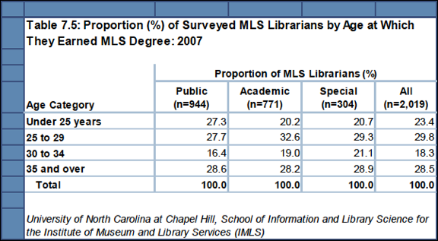
(Figure 17)
Consistent with an older staff, “MLS librarians say they anticipate retiring at a much older age than the actual retirement age of those who retired in 2007” (Griffiths et al. 136).
Race: The state of racial diversity among librarians is straightforward according to the IMLS. With whites accounting for 77.4% of MLS librarians, “non-white MLS librarians . . . tend to be underrepresented.”
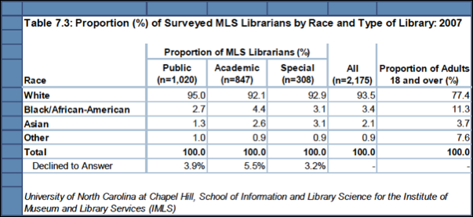
(Figure 18)
The match between these results and the LAUC profile is easy to see. Librarians as a whole are heavily female, somewhat older, and overwhelmingly white.
Comparison with Library Type
Much of the national data took the form of comparisons between three types of librarians—public, academic, and special—and it is here that much of the work of the studies was done and where much of the nuance resides, often in the form of cross-correlations between variables. It is appropriate to compare the LAUC data to this material. The total number of variables and comparisons is prohibitively large from the 300+ pages of the original studies, so only the most central are discussed here.
Gender: While the ARL study notes that “librarianship is predominantly and persistently a woman’s profession” (stretching back to the time of Melvil Dewey), the imbalance is less for academic librarians (74.3% female) compared to public librarians (83.8% female) and school librarians (91.0% female) (Griffiths et al. 66; Kyrillidou and Morris 11). With female librarians at 71.7% in the 2013 survey, LAUC has about the same gender distribution as other academic librarians but a trifle more balanced.
Gender vs. Age: Female librarians of all library types “are slightly older (46 average age vs. 45) and a higher proportion are over 50 (54.6% vs. 38.7%).” However these relationships reverse for academic librarianship where female librarians “tend to be younger than males although academic librarians as a group tend to be older than the other types of librarians” (Griffiths et al. 67, 121). The LAUC 2013 data reverses this trend with females generally older than males. The largest fraction of males (39.4%) were in the 45-54 age group while the largest fraction of females (39.4%) were in the next older category of 55-64.
Gender vs. Cause to Leave: The IMLS data shows that a number of causes for leaving the profession are heavily gender dependent.
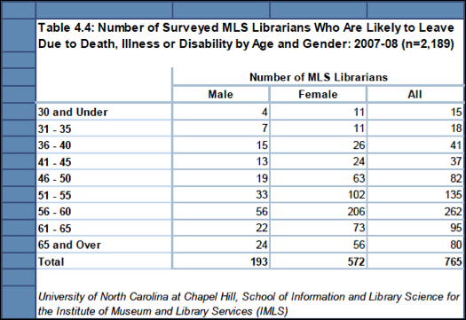
(Figure 19)
Gender vs. Salary: The gender difference in salary is particularly “stark” in public libraries where the average male salary was 24.4% higher than females. While a difference remains in academic and special libraries, 1.5% and 3.7% higher for males respectively, it is much more equitable (Griffiths et al. 125). The ARL concurs. “In 2011-2012 the overall salary for women was only 96.022% of that of men for the 115 ARL university libraries (compared to 96.05% in 2010-2011). This suggests a slow, long-term trend towards closure of the gender gap in ARL libraries—in 1980-1981, women in ARL libraries made roughly 87% that of men” (Kyrillidou and Morris 11). It would appear that LAUC may have closed the gap already. A cross-correlation of the 2013 survey of Gender vs. Salary records essentially no difference in the salaries of the two genders. That is the difference between male and female salaries across rank remains more or less constant. They rise and fall together.
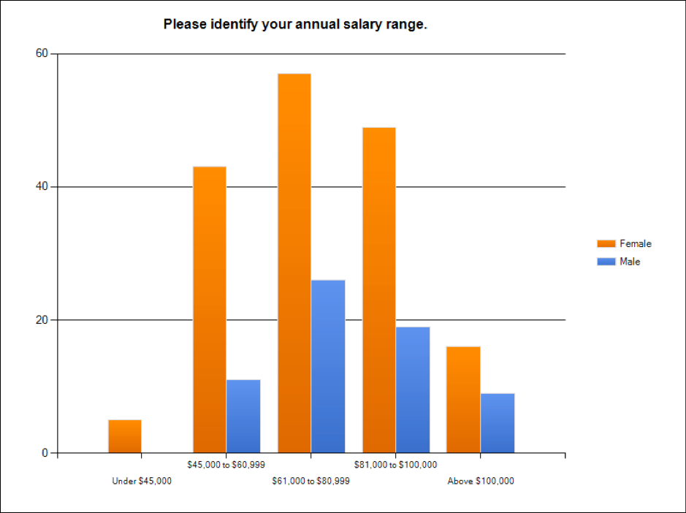
(Figure 20)
Salary: Among the three types of libraries, public libraries have far lower salaries than academic and special with one-third of all public librarians receiving less than $40,000 annually.
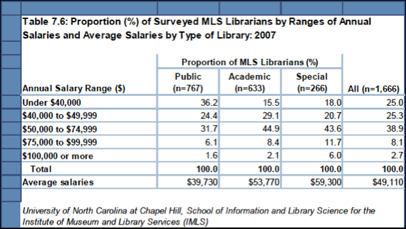
(Figure 21)
Salary vs. Library Size: “Library size, as measured by the number of professional staff, is another significant determinant of salary. As a rule, the largest libraries tend to pay the highest average salaries, not only overall, but for specific positions, as well . . . The largest libraries, those with more than 110 staff, reported the highest average salary, $75,974…” (Kyrillidou and Morris 13). This fact would tend to favor UC libraries with their generally middle to large size. In fact, for the data reported on the 2013 survey in terms of salary ranges, an inspection shows that the average falls on the high end of the $61,000 to $80,000 range, almost exactly that of the average salary for the largest libraries.
Salary vs. Age: ARL has a table showing the distribution of salary by age. The salaries increase with age as one might expect.
Average Salaries of ARL University Librarians by Position and Years of Experience, FY 2011-2012
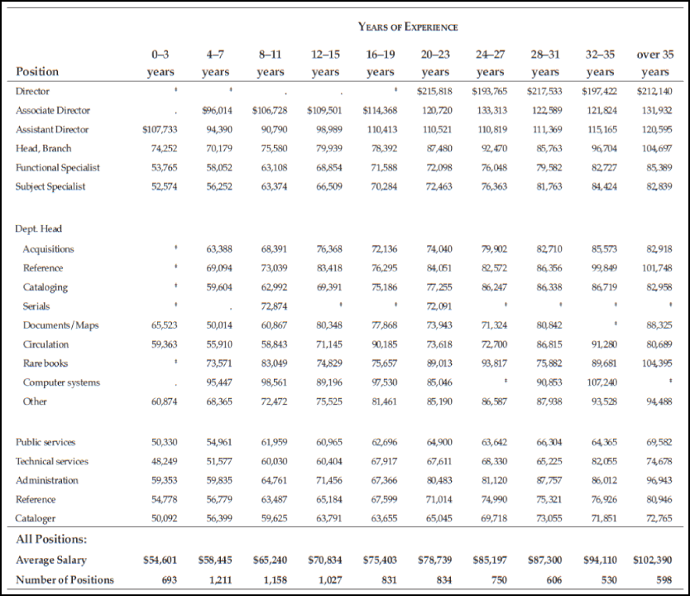
(Figure 22)
It is difficult to make a comparison with the LAUC data. For instance, the average salary of $75,403 achieved by the category of 16-19 years of experience in the ARL data is achieved by the LAUC membership after less than 10 years.
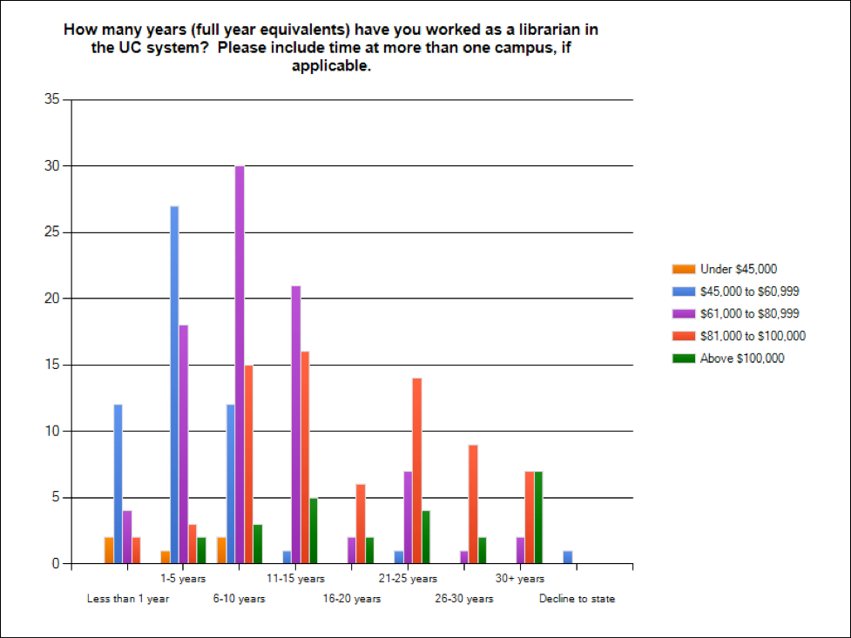
(Figure 23)
However this graph refers only to years worked at UC. Other data indicate a good deal of experience in other information professions which would presumably impact salary, and it is impossible to disentangle which respondents acquired experience outside of UC. This circumstance would tend to subtract from the apparent higher salaries of UC shown in the graph above compared to the national data, but how much is impossible to say.
Salary vs. Rank vs. Gender: The ARL study suggests complications and reversals of expectation here. “Since 2008-2009, the average salary for female directors was slightly higher than that of their male counterparts. However, for the second consecutive year the trend was reversed, with male directors earning more than female directors; furthermore the number of women in the top administrative library position decreased to 65 out of 112 total director positions reported in 2011-2012” (Kyrillidou and Morris 11). Ignoring small fluctuations, one notes the general parity between salary, gender, and rank suggesting that academic libraries have made great strides against the glass ceiling. The larger problem is bringing other ranks below administration, where the salaries of women lag behind men’s, up to par, but, as mentioned above, the trend is towards closure.
1%: ARL data indicates that the salary of the top “1%” of librarians falls at about $175,000 (Kyrillidou and Morris 19).
Race: “The racial mix of MLS librarians is very similar among the three types of MLS librarians, although public libraries have a slightly higher proportion of white MLS librarians” (Griffiths et al. 122). Unfortunately, the racial imbalance across library types is disturbingly high. ARL records 85.8% of staff are white (Kyrillidou and Morris 8). The LAUC 2013 survey data compares well with 77% whites reported.
Race vs. Gender vs. Salary: ARL reports that the salary inequality between men and women is reproduced for minorities with women making an average of $67,048 and men $71,825. The LAUC survey has no comparable data.
Geography
In addition to comparing the LAUC data with types of libraries, the committee also compared it geographically with regions of the country. This was the only regional data that could be gathered. Two results emerged.
Race: “Proportionately to other regions, there are more minorities in the Pacific, South Atlantic, West South Central, and Middle Atlantic regions” (Kyrillidou and Morris 9). Without mining the exact figures from the LAUC survey, it can be said that UC, on the West Coast, is in one of the more favorable regions for minority representation.
Salary: The average salary for the Pacific region at $76,666 is slightly higher than the average national salary at $74,429. As above, this puts UC in a good place, and short of average salary data, the LAUC survey shows that the largest category of salary is $61,000 to $80,000 with certain indicators pointing the average to the high end of the scale at about the same figure as the Pacific average. As an additional wrinkle, UC salaries tend to be on the low side at the beginning level with an ARL rank clustering in the high 50s. The beginning and medial salaries show more variation within the UC system, but unmistakably the institutional rank increases with UC Davis ranking as high as 6 in medial salary for 2012 (Kyrillidou and Morris 38).
Discussion
While the absolute numbers of diversity for LAUC show a number of imbalances in the attributes of the core profile, comparison with regional and national data are more favorable. Academic libraries compare favorably to both public and special libraries in almost every measure of diversity except for age. Academic librarians tend to be older. However, this attribute is tied to their higher salaries and greater versatility in their careers. Superimposed on top of this categorical comparison, the LAUC membership compares favorably even to other academic libraries in almost every respect. Similarly, UC displays the geographical advantages of the Pacific region in terms of minority distribution and salary.
II. Professional Issues
The remainder of the report departs slightly from the strict terms of the charge by reviewing data about professional issues, especially staff shortages and training issues, that were the emphasis of the national data. Yet this shift in focus fulfills a larger sense of the comparison with other data requested in the original charge. Moreover, it is deeply tied to issues of diversity since, in the face of a potentially severe shortfall of staff, libraries will be pressed to hire anybody let alone diverse staff. We will examine the staff issues laid out in the national reports and the degree to which they relate to UC as indicated by our surveys.
Shortage
The fundamental issue of staff shortage is a complex one that is approached through a variety of statistics. The total number of MLS librarians is currently 100,963 in the United States. Attrition over the next ten years will require 53,794 new librarians as replacements along with an additional 4,762 new positions created over that period. (This trend is offset somewhat by a decrease in the number of new positions created over that time from a high of 685 down to 248—an independent and somewhat worrying trend in its own right.) In any case, the figures indicate the need for 62,320 new librarians in the next decade just to maintain the size of the profession (Griffiths et al. 13).
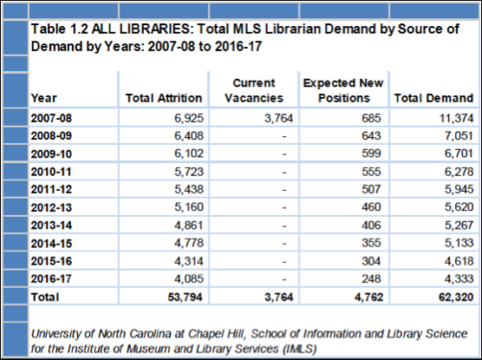
(Figure 24)
To meet this need, IMLS claims that “the total number of Master’s degrees in Library Science awarded by U.S. institutions has fluctuated between 4,500 and 8,000 over the past 35 years (Griffiths et al. 57). The study concludes that “the deficiency in supply results in an effective demand and that it would require a doubling to quadrupling of the annual supply for the entire ten-year period” (Griffiths et al. 14). IMLS claims that there are 29,278 academic librarians in the United States (Griffiths et al. 53). Figures are not available for the demand for academic librarians although the study notes that “academic libraries seem to have low vacancy proportions” (Griffiths et al. 120). As seen elsewhere, the picture of academic libraries is rosier than for other parts of the profession. But it would be wise for UC to be prepared for a shortage of staff. The LAUC surveys did not yield any information on this issue.
There are other complicating factors. Libraries are in significant competition with industries in information technology and education for qualified personnel. “The number of librarians working outside libraries is also expected to grow. Currently an estimated 20-25% of qualified librarians take positions outside libraries, mostly performing librarian-like duties” (Griffiths et al. 56). This circumstance “contributes to the fact that 28.5% are thirty-five and older when they receive their MLS degree” (Griffiths et al. 29). The two LAUC surveys correlate this trend of a somewhat older workforce that has moved around between institutions and careers. The smaller career window available to libraries as a result contributes to the shortage of librarians.
Skills
Also relevant for future staffing is the preparation and skill set. “In terms of the average importance ratings for each competency, the same three competencies emerged at the top for all three library types (although with the rank order different in public libraries from that in academic and special libraries). As shown in [Figure 24], the top three are leadership skills (4.43, 4.44 and 4.31 in academic, special and public, respectively), management knowledge and skills (4.42, 4.41 and 4.35) and knowledge of planning and budgeting principles (4.42, 4.41 and 4.35)” (Griffiths et al. 186).
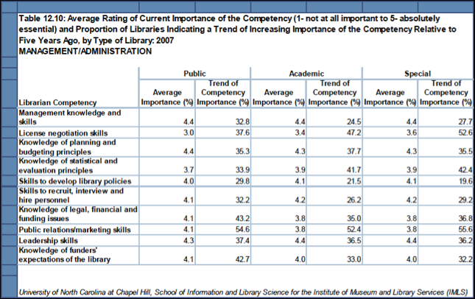
(Figure 25)
Yet the study also notes some “striking differences” between the three types of libraries. “Knowledge of subject specializations was more important for academic and special libraries (51.0% and 57.8%) than public libraries (29%). Similarly, making presentations to groups was more important for academic and special libraries (93.7% and 91.1% versus 76.9%), while knowledge of behavior management skills was somewhat more important for public libraries (84.5% versus 76.2% and 75.3%)” (Griffiths et al. 187). There was no information in the LAUC surveys about the most desired skills of librarians among the membership. It would be reasonable to take the results above as a profile of the librarian of the future and test it against the perceptions of LAUC in future surveys.
Job Satisfaction
This issue is evidently central to retention which is basic to staffing. Overall satisfaction is high. “About three-fourths of MLS librarians say they would choose librarianship again and this attitude is consistent among the three types of librarians” (Griffiths et al. 141).
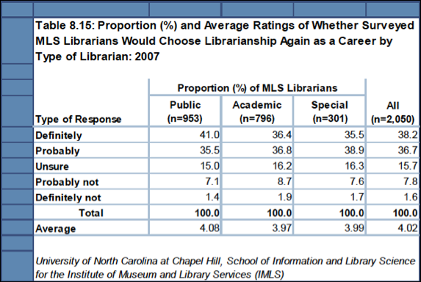
(Figure 26)
But while there is satisfaction with the profession as a whole, there are other specific factors that vary widely among libraries. As elsewhere, academic libraries compare favorably to other types. “More academic libraries allow time for sick leave (96.5% vs. about 89.0% for other libraries), training/education (95.2% vs. 79.2% for public and 88.8% for special libraries), and maternity or family leave (93.3% vs. 84.1% for public and 79.7% for special libraries)” (Griffiths et al. 155). The LAUC surveys have no specific data on these points, but one would presume that the numbers correspond with the relatively advantageous ones of academic libraries.
One additional factor in job satisfaction is amount of supervisory responsibility. “MLS librarians rate their satisfaction with an opportunity for advancement by far the lowest of five work-related issues” (Griffiths et al. 28). Actual numbers for MLS librarians as a group are: “About 45 percent of MLS librarians work in a nonsupervisory capacity” (Griffiths et al. 28). The LAUC 2013 survey shows comparable numbers of those without supervisory positions but slightly higher: 53.4% of LAUC librarians work in a nonsupervisory capacity.
In terms of staff preparation and shortages, LAUC is comparable to other academic librarians and doing better than the other two categories of libraries by most measures, but LAUC still faces the prospect of a significant staff shortage in the future.
Recommendations
The LAUC surveys should be maintained for longitudinal data. The results should be mined to revise future surveys in response to changes in the profession and to provide a basis for LAUC to advocate for new staff policies.
Works Cited
Griffiths, Jose-Marie, et al. A National Study of the Future of Librarians in the Workforce.” University of North Carolina at Chapel Hill, 2009.
Kyrillidou, Martha, and Shaneka Morris. ARL Annual Salary Survey 2011-2012. Washington D.C.: Association of Research Libraries, 2012.

(Griffiths et al.; Kyrillidou and Morris)

